**DS**

**Striver A2Z DS Series**

**Sorting**

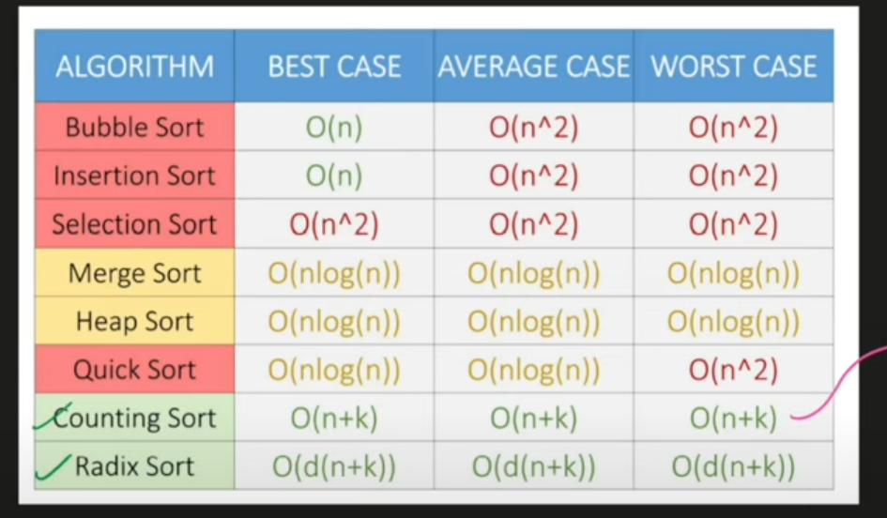

**Array easy**

**Q1**

[**Largest Element in an Array**](https://takeuforward.org/data-structure/find-the-largest-element-in-an-array/)

Just find the maximum element by *max_element(arr.begin(), arr.end());

**Q2**

[**Second Largest Element in an Array without sorting**](https://takeuforward.org/data-structure/find-second-smallest-and-second-largest-element-in-an-array/)

Start max from arr[0] and second_max from -1.

If arr[i] is greater than max then put max in second max and update max.

Else if arr[i] is greater than second max and arr[i] is not equal to max then update second max only.

In the end return second max.

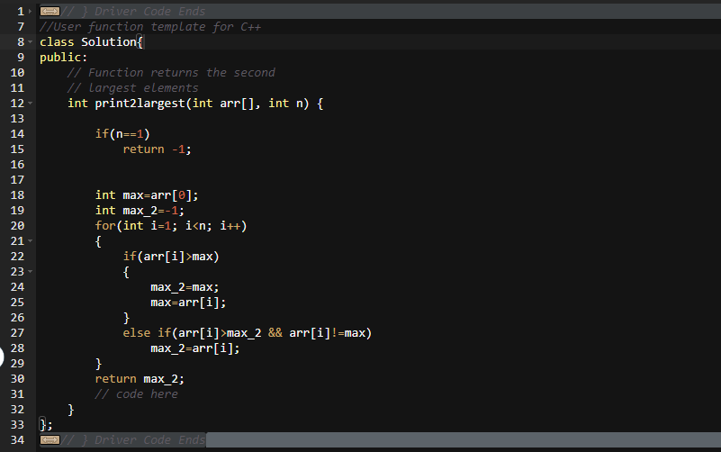

**Q3**

[**Check if the array is sorted**](https://takeuforward.org/data-structure/check-if-an-array-is-sorted/)

* Keep a count and initialize it from 0.
* If the arr[i]>arr[j] then increase count by 1.
* Traverse the whole array and in the end check if arr[0]<arr[n]. if this is true then increase count by one.
* If in the end count is less than equal to 1 then the array is sorted else not.

**Q4**

[**Remove duplicates from Sorted array**](https://takeuforward.org/data-structure/remove-duplicates-in-place-from-sorted-array/)

* Put i=0;
* Traverse the array from 1 to n and check if arr[i]!=arr[j].
* If it is true then put arr[j] at arr[i+1] and increase I by 1.
* In the end return i+1.
* This is the double pointer method in which one pointer is used for iteration and the other is used for storing all unique elements at their positions.

**Q5**

**To rotate an array right by k steps**

* Reverse the array from begin to n-k.
* Reverse the array from n-k to the end.
* Reverse the complete array.

**Q6**

**To rotate an array left by k steps**

* Reverse the first k elements of the array.
* Reverse the last n-k elements of the array.
* Reverse the whole array.

**Q7**

[**Move Zeros to end**](https://takeuforward.org/data-structure/move-all-zeros-to-the-end-of-the-array/)

* take 2 pointers I and j.
* move I to every 0 element.
* Start j from i+1 till it reaches non zero and swap them.

**Q10**

**Find the missing number in an array**

**First Approach:**

* Calculate sum of all the terms.
* Calculate sum of first n terms.
* Subtract.

**Second Approach**

* Do XOR operation of the first n characters with the given all characters.

**Q11**

[**Maximum Consecutive Ones**](https://takeuforward.org/data-structure/count-maximum-consecutive-ones-in-the-array/)

* Just keep a maxima variable and reset your count variable whenever you encounter a zero.

**Q12**

[**Find the number that appears once, and other numbers twice.**](https://takeuforward.org/arrays/find-the-number-that-appears-once-and-the-other-numbers-twice/)

* Take XOR of everything and you will get the number.

**Q9**

**Union of Two Sorted Arrays**

**First Approach: (Use Sets)**

* Insert everything in a set.
* Remove everything from that set into a vector and return it.

**Q13**

**Longest subarray with sum k**

In a subarray you have to pick only elements together you cannot skip an element in between.

The first two approaches are of n3 and n2**.**

**The better solution:**

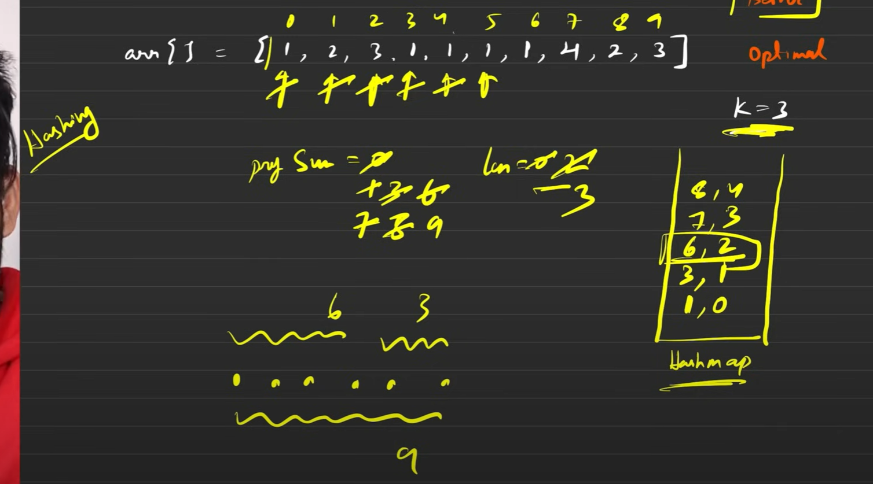

* Create a hashmap.
* Start iterating the array and keep a prefix sum variable in which you add the next element you reach everytime.
* Insert that prefix sum with the index at which you get that sum in the hashmap.
* Now you also have to create a variable of max_length which will hold the maximum length of the subarray.
* Now as you are traversing the sum of the prefix will increase. You will have to search like agar total prefix sum waha tak x hai and we need k then kya hamare paas x-k already hashmap me present hai?
* If yes then see wo sum konse index tak hume mil gya tha and see which index you are standing at and subtract those two to get a new length and update if it is greater than last length.
* **This codes will only work for positives as we have left the case for zeros. When zeroes exist in our code we need to get the total prefix sum as left as possible that is if we have prefix sum 5 at index 2 and we have 3 zeroes then we will have prefix sum 5 till index 5 as well and we will update our hashmap with this new data. We do not have to update in the hashmap if the same already existed.**
* **Now this is the optimal solution that exists for positives, negatives and zeroes.**

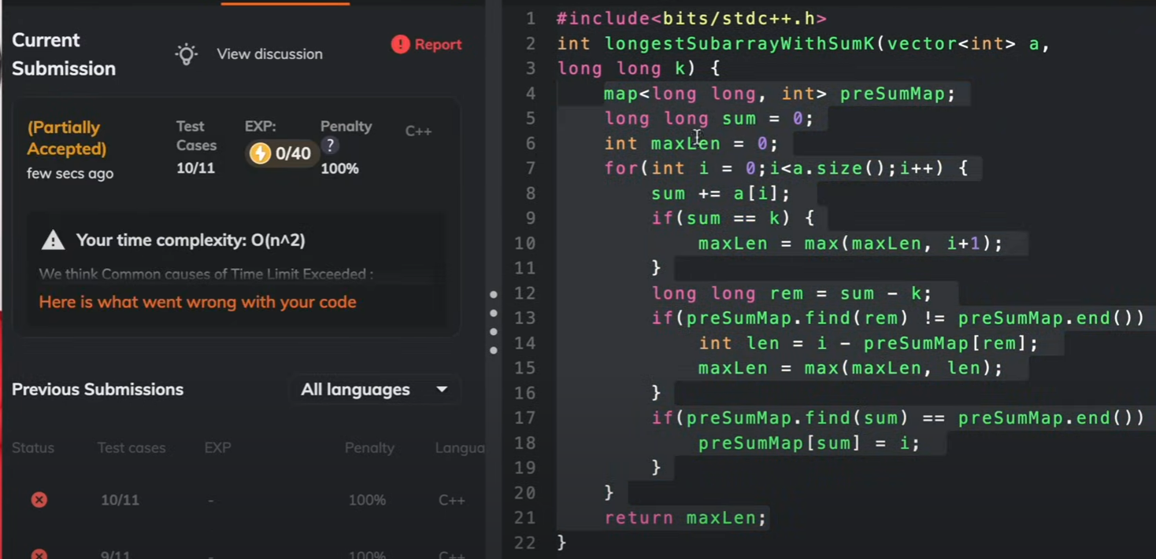

**For only positives another optimal solution can be: (2nd approach)**

* in this approach we are gonna use the two pointer approach.
* We will calculate the sum as we traverse the array.
* i will be kept at the first element and j will move and the sum will increase.
* When the sum exceeds the value of k then we move our i from back to reduce the overall sum.
* We keep checking if we get the sum equal to k and if we get then we save that length in some variable and return the largest length possible.
* **This is optimal solution for positives as well as for zeros with TC of 2N as the second inner while loop runs a total for O(N) and the outer loop runs for O(N) and SC of O(1).**

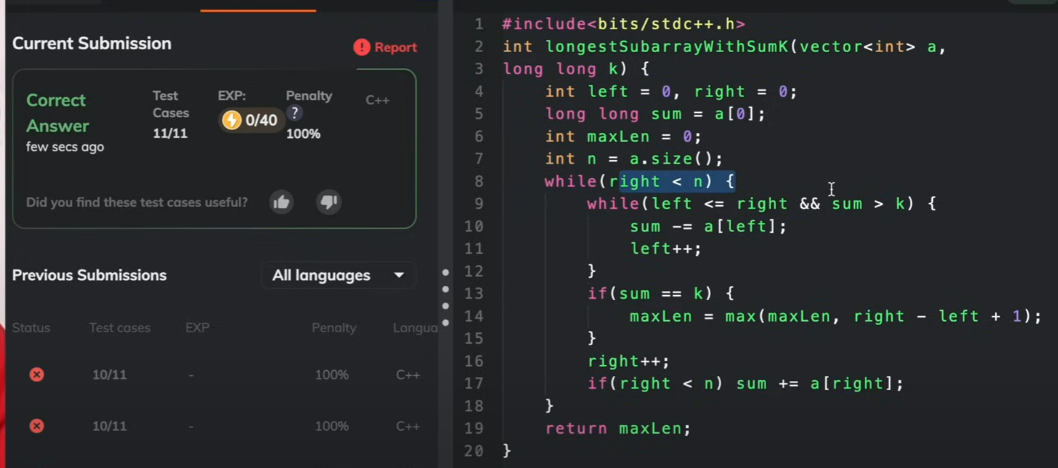

**Array Medium**

**Q4**

[Kadane's Algorithm, maximum subarra…](https://takeuforward.org/data-structure/kadanes-algorithm-maximum-subarray-sum-in-an-array/)

Optimal Approach:

Start from the 0th index and calculate the sum and if the sum goes negative at any time then it is not advantageous to carry that sum forward and so we start from sum=0 again from the next element onwards.

Then we maintain another variable to store the maximum sum and if we get any sum greater than that variable we update that variable and in the end we return the maxsum.

**Q5**

[Print subarray with maximum subarra…](https://takeuforward.org/data-structure/kadanes-algorithm-maximum-subarray-sum-in-an-array/)

Optimal Approach:

Same as above just when the sum is less than zero and you update the sum=0 keep an index at that position and when you get a maximum sum keep the other index at that position and in the return difference of both of them.

**Q6**  [Stock Buy and Sell](https://takeuforward.org/data-structure/stock-buy-and-sell/)

**Optimal Approach:**

You keep profit equal to 0 in the beginning. And the minimum cost as the beginning of the array. Everyday you keep a track of the previous minimum and the maximum profit you make by subtracting the min cost with the cost at that day and keep updating the maximum profit in a variable and in the end return that variable.

**Q7**

[Rearrange the array in alternating …](https://takeuforward.org/arrays/rearrange-array-elements-by-sign/)

**Optimal Approach:**

You keep two indexes one for positive and one for negative and when you encounter a positive number you put it on the index for positives and then update it by two and same goes for the negatives.

**Q8**

[Next Permutation](https://takeuforward.org/data-structure/next_permutation-find-next-lexicographically-greater-permutation/)

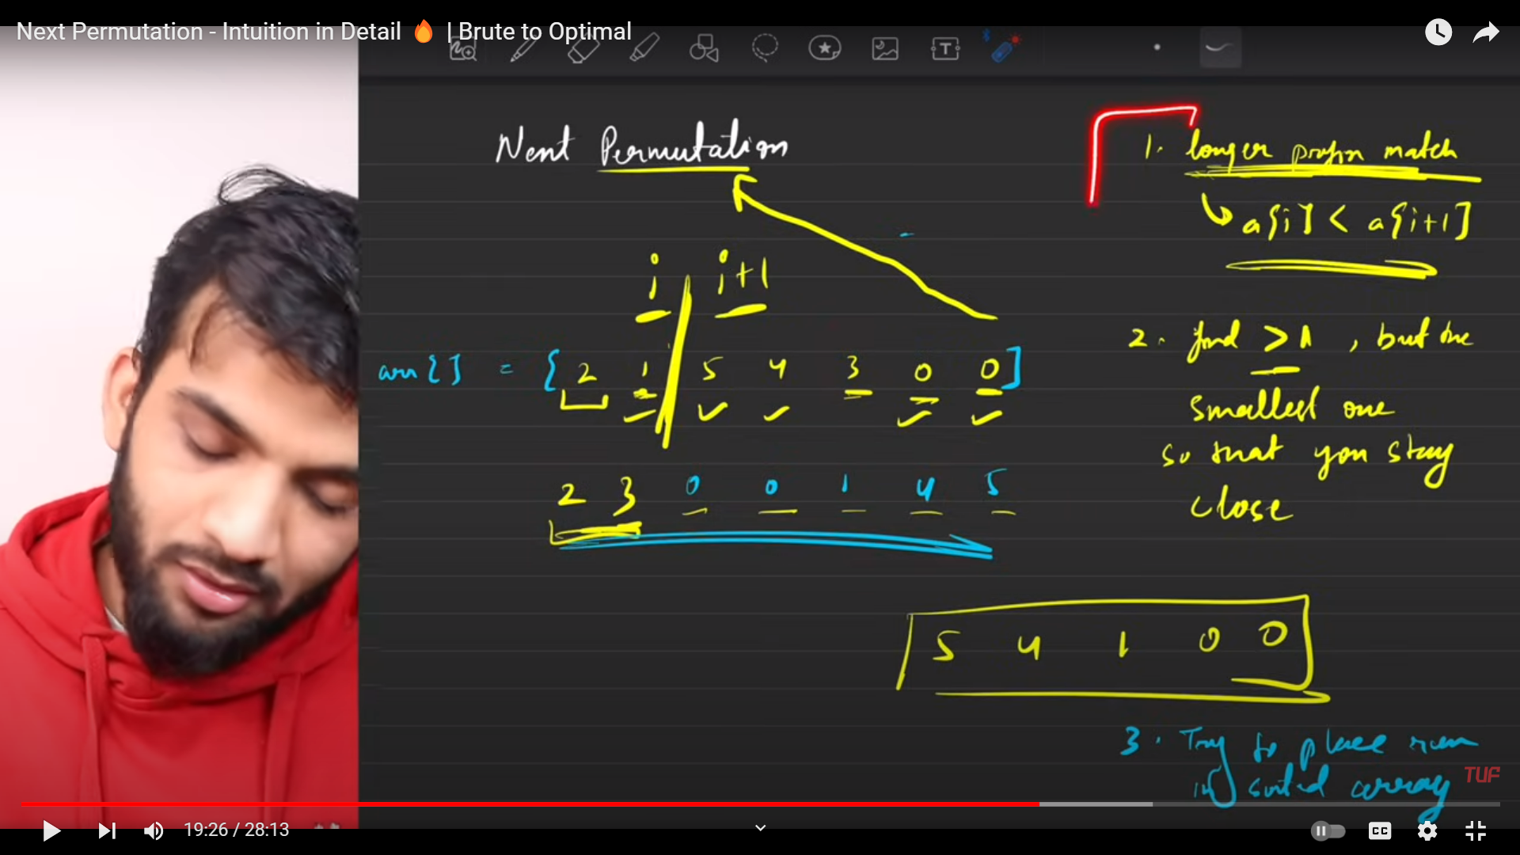

**Q10** [Longest Consecutive Sequence in an …](https://takeuforward.org/data-structure/longest-consecutive-sequence-in-an-array/)

Optimal Approach:

In this approach we will use unordered_set. We will store all of the data in the set and then we will search of a particular data x, x-1 exists in the set. If it does then we do not take that into consideration and try for the next element. If we get an element whose x-1 does not appears then we start count =1 from that element and then search for x+1 and x+2 and so on till we can find and store the count in the longest variable which stores the last longest found. In the end we return that longest value.

**Q11** [[Set Matrix Zeros](https://takeuforward.org/data-structure/set-matrix-zero/)](https://takeuforward.org/data-structure/longest-consecutive-sequence-in-an-array/)

Optimal Approach:

In this approach we will have a 2d vector and we will first take only one extra variable col0. We will use the first row and the first column to store the values of the rows and columns that have to be changed to 0 in the end. Now we will traverse the whole vector one by one and if we encounter any zero then we will put 0 in the first row and the first column except that if there has to be a zero when the column no is 0 then we change that one extra variable to zero.

Then we will iterate in the vector again leaving the first row and the first column and then we will put every element as 0 if the first row or the first column contains a zero and then we will change the first row depending on if the first element of the vector is 0. If it is then the whole 1st row will be zero and we will do this using 1 loop and then we check if the col0 = 0. If it is then the first column also changes to 0.

**Q12** [[Rotate Matrix by 90 degrees](https://takeuforward.org/data-structure/rotate-image-by-90-degree/)](https://takeuforward.org/data-structure/longest-consecutive-sequence-in-an-array/)

Optimal Approach:

In this problem you have to take transpose of the matrix and then reverse each row and that will give you the optimal solution.

**Q13**  [Print the matrix in spiral manner](https://takeuforward.org/data-structure/spiral-traversal-of-matrix/)

Optimal Approach:

In this problem we create 4 variable left right top and bottom and we traverse from left to right then bottom then left and then top.

We keep an outer loop which runs when left <= right && top<= bottom and then we keep on going in spirals and increasing the left and top and decreasing the right and bottom and also we keep a check that like if there was only one row then once we have moved from left to right we should not count it again from right to left and therefore we keep a check before traversing from right to left if top<= bottom and same goes for going from bottom to top again after going from top to bottom we check left to right.

**Q14** [[Count subarrays with given sum](https://takeuforward.org/arrays/count-subarray-sum-equals-k/)](https://takeuforward.org/data-structure/spiral-traversal-of-matrix/)

Optimal Approach:

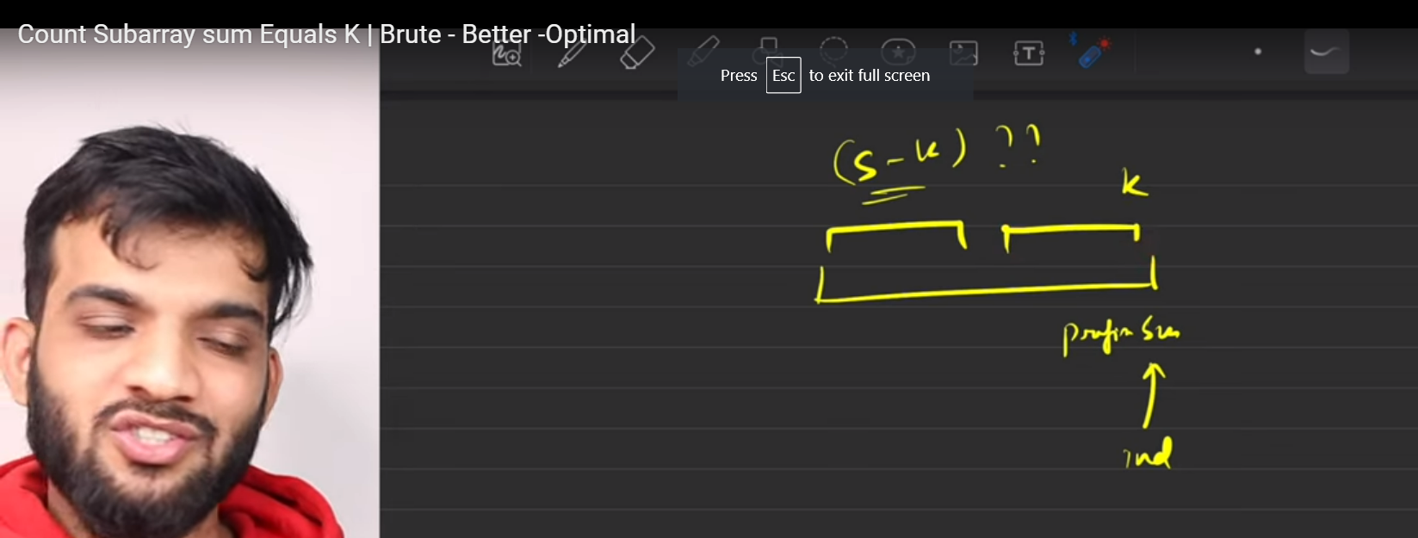

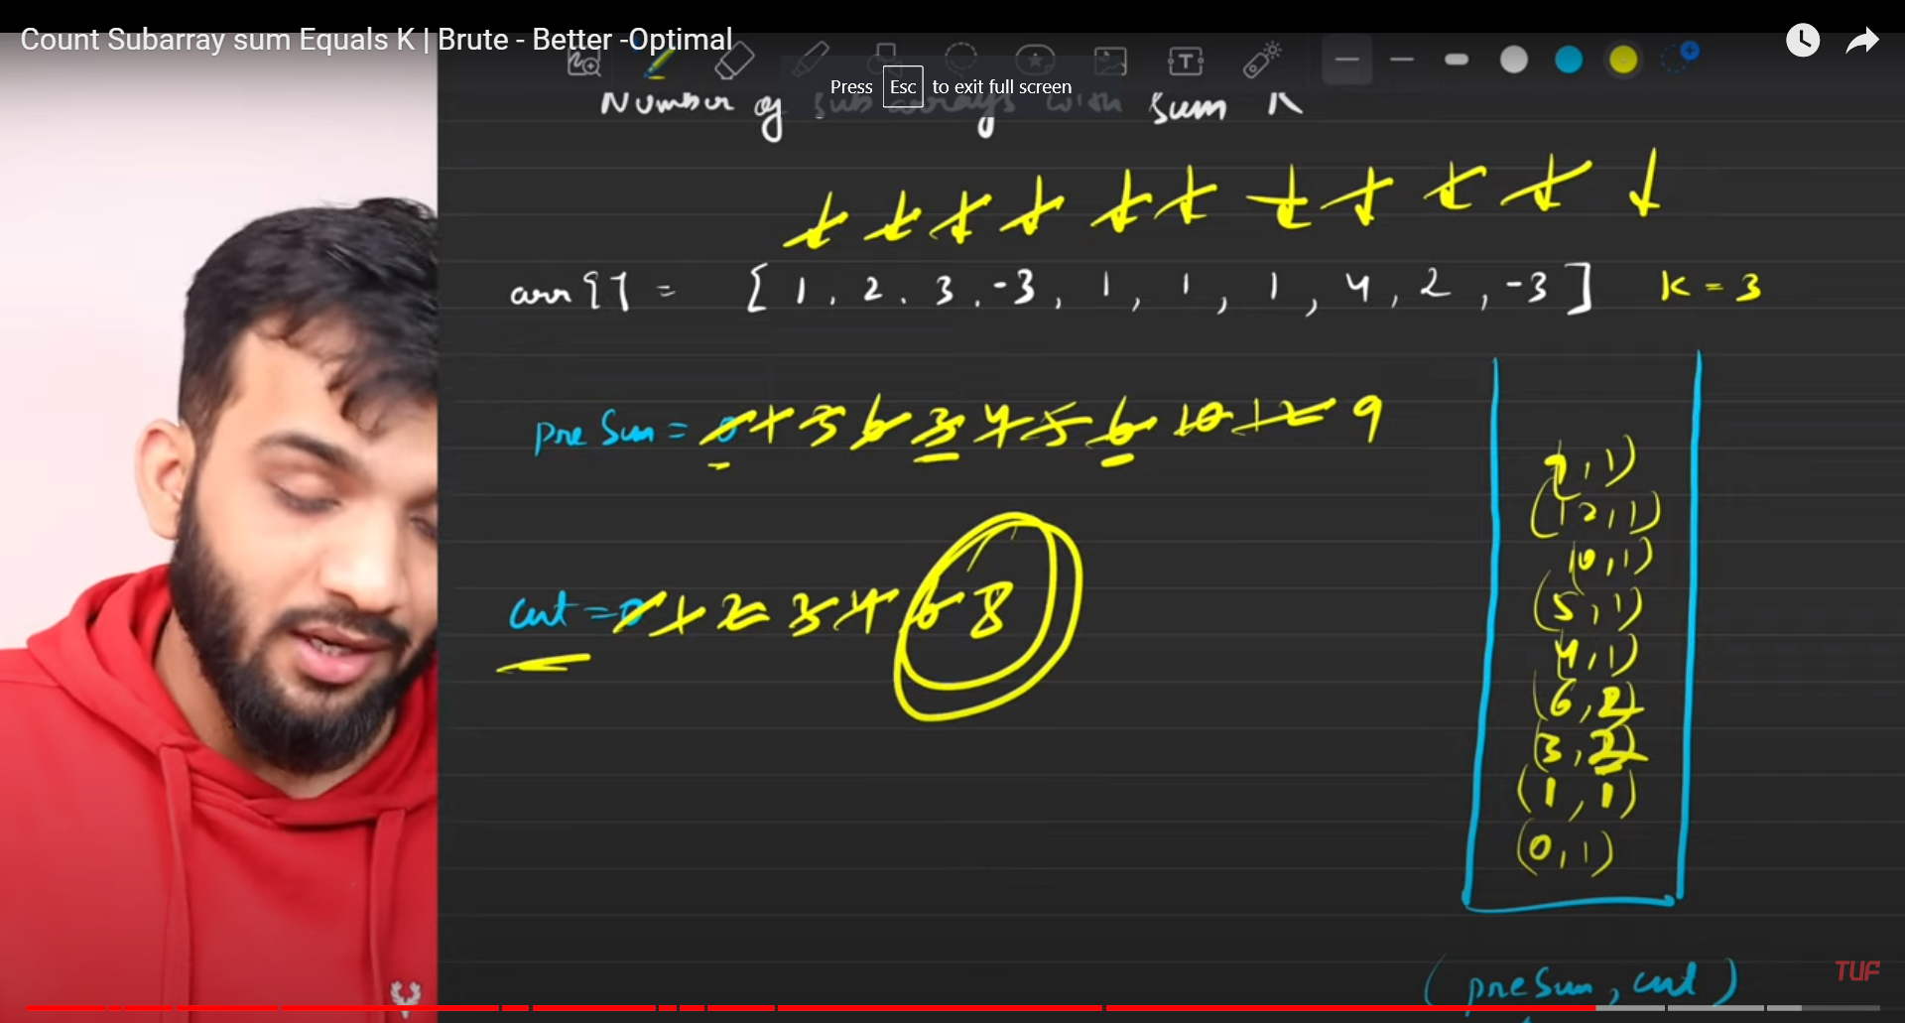

So in this problem we calculate presum and keep a count of the number of occurrences of that.

We create a hashmap in this question and insert the values of the presum and its occurrences in the hashmap.

Then we insert (0,1) also in the hashmap as it has a significant use of not taking any element in the presum.

We traverse on the array and keep on calculating the presum and add we also keep a counter as count.

When we have a total presum of x and we need to find out the number of subarrays with sum k then we will have to see how many presum with value of (x-k) are present in the hashmap.

In the end we have to return the value of count.

**Array Hard**

**Q1** [[[Pascal's Triangle](https://takeuforward.org/data-structure/program-to-generate-pascals-triangle/)](https://takeuforward.org/arrays/count-subarray-sum-equals-k/)](https://takeuforward.org/data-structure/spiral-traversal-of-matrix/)

**Optimal Approach:**

There can be 3 types of problems in this.

Problem1) find a particular row and column element of the pascal triangle.

If we are given row r and column c then the answer is r-1Cc-1

To calculate this value we will use this method.

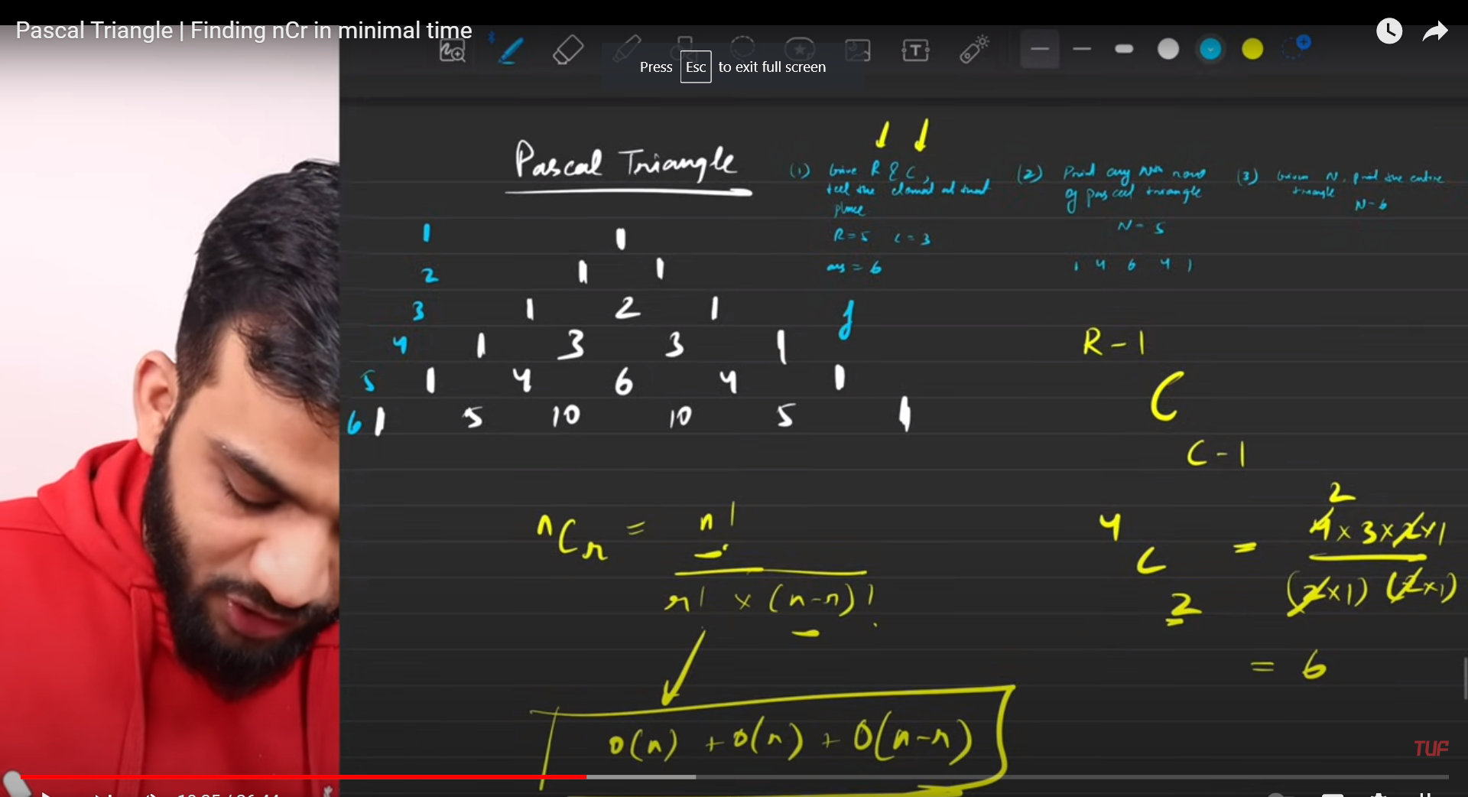

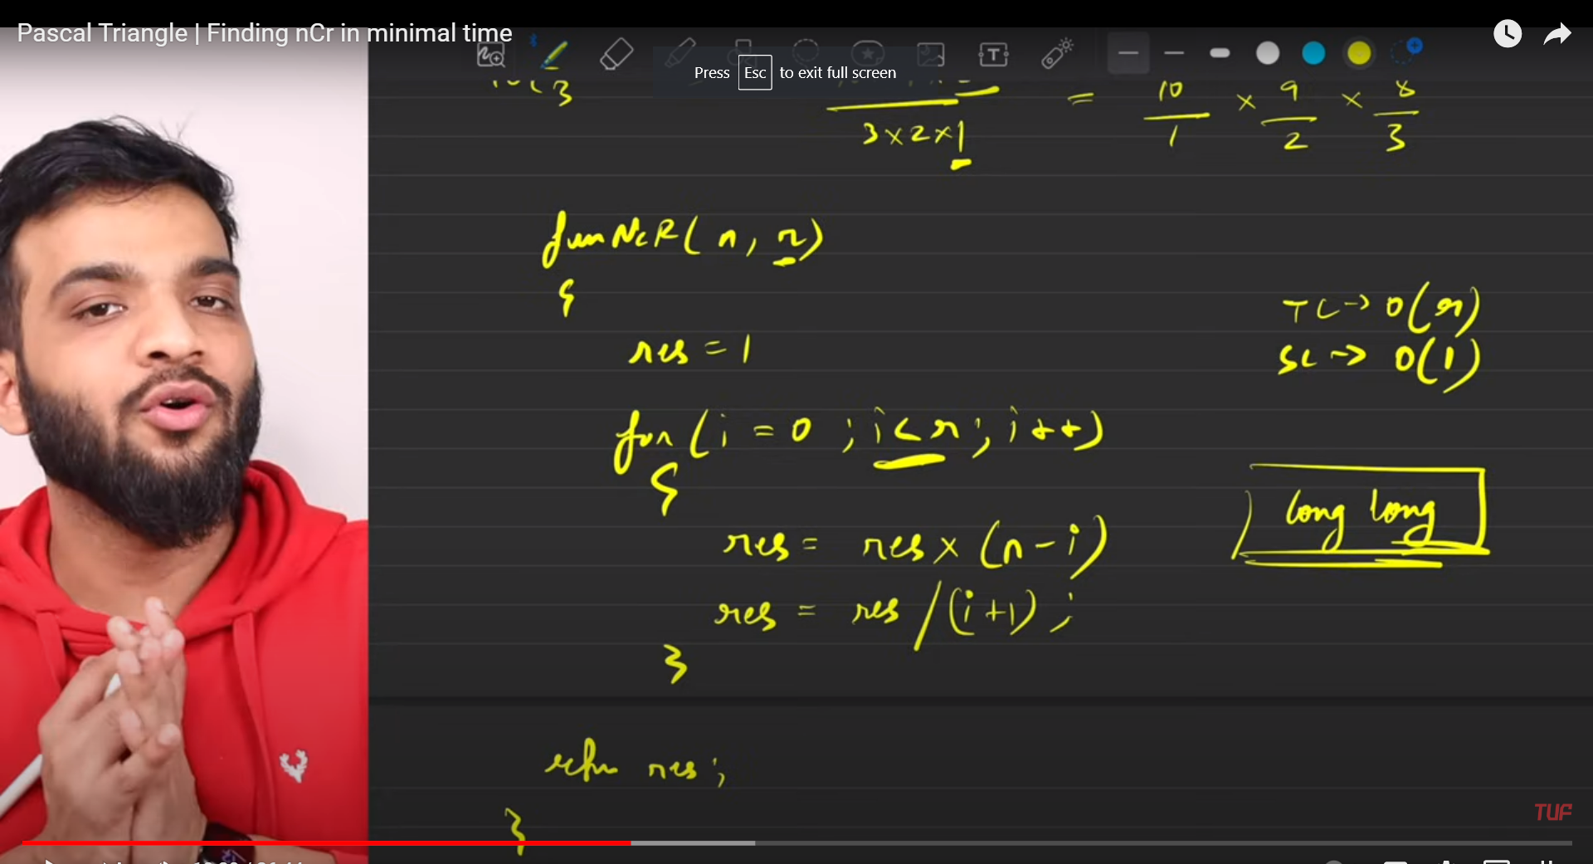

In the second type of question you may be asked to print a given row number of the pascal triangle.

For this type of question you can use the formula

Ans=ans*(row-col);

Ans=ans/col;

Where ans is the value and we use a loop to iterate through the column.

3) To solve the third type of problem we have to compute the entire pascal triangle to a given row number.

Use the 2nd method to calculate the elements of each row and use a loop to iterate through all the rows.

**Q2**

[Majority Element (n/3 times)](https://takeuforward.org/data-structure/majority-elementsn-3-times-find-the-elements-that-appears-more-than-n-3-times-in-the-array/)

**Optimal Approach:**

In this problem we again use the intuition of the majority element n/2 times.

We keep a count 1, element 1 and count 2, element 2.

We initialize the element 1 and element 2 and increase the counter as we see more of them but if we get any element that is different from what is stored in element 1 and element 2 then we decrease the counter of both of count 1 and count 2.

If any reaches zero we initialize a new element and make sure that the new element is not already stored in the other variable.

After we have traversed the whole of the array we have the probable answers in element 1 and element 2. We count the frequency of both of these again using the loop and if we get them to be more than the floor value +1 then it is the correct answer and we include it in the vector and return it.

**Binary Search:**

Q1) [**Binary Search to find X in sorted array**](https://takeuforward.org/data-structure/binary-search-explained/)

* Just plain normal binary search

Q2) [**Implement Lower Bound**](https://takeuforward.org/arrays/implement-lower-bound-bs-2/)



* You keep using binary search in the array and look for the above condition. If the above condition is true, then that can be your lower bound and you keep looking on further left for any more answer you can find.

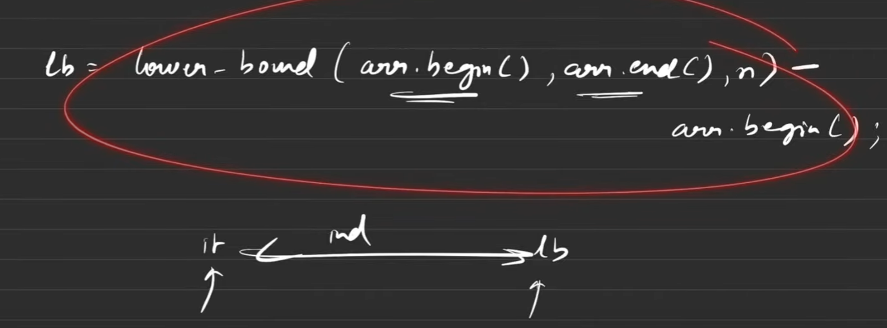

STL way to calculate lower bound in c++.

In case of array you can write instead of arr.begin and arr.end you can write arr, arr+n

Q2) **Floor in Sorted Array:**

* you start your ans variable with -1.
* You use binary search and try to find arr[mid]<=x. if this is true it can be your answer and you look for further right for more possible answers.

Q3) **Upper Bound**

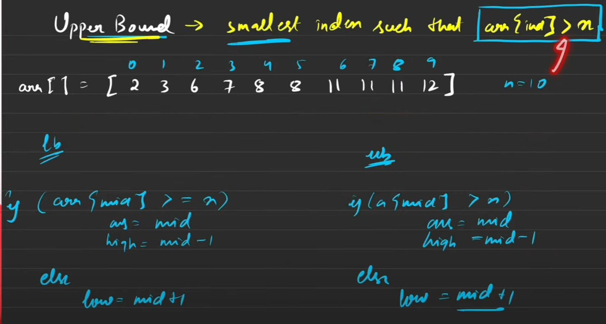

C++ STL

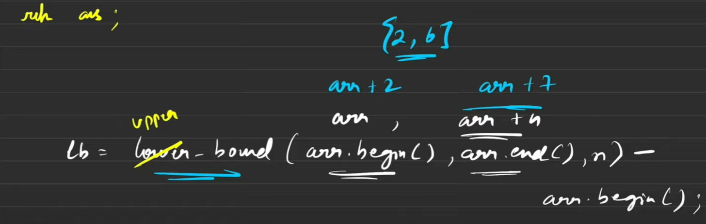

Q4) [**Search Insert Position**](https://takeuforward.org/arrays/search-insert-position/)

* Use normal binary search
* If arr[mid]=target then it is answer.
* If arr[mid]<target then mid+1 can be answer we search for more on the right side and in the end we return ans.

Q5) Floor/Ceil Sorted Array



* if arr[mid]==target then floor ceil are equal to a[mid].
* If arr[mid]>target then ceil = arr[mid] and look on the left side.
* If arr[mid]<target then floor = arr[mid] and look on the right side.

**Q6)** [**Find the first or last occurrence of a given number in a sorted array**](https://takeuforward.org/data-structure/last-occurrence-in-a-sorted-array/)

* In this problem use concept of upper bound and lower bound with 2 restrictions.
* Use STL of upper bound and lower bound as available a little above and then take care of the two restrictions. Also subtract one from the upper bound.
* The restriction is for lower bound as if the element is not present the lower bound will show to the next element greater than the target so once we get the lower bound make sure to check that at that index the element present is really our target.
* The second restriction is if the target is greater than all element in our array then the lower bound will be equal to a hypothetical value of the size of the array or vector. So we check if the value of the lower bound is equal to the size of array, then also we have to return -1,-1 as the element is not present in the array.

**Q7)** [**Count occurrences of a number in a sorted array with duplicates**](https://takeuforward.org/data-structure/count-occurrences-in-sorted-array/)

* Just calculate lowerbound and upperbound as in above case and return ub-lb+1.
* If any of those two edge cases is true then return 0.

**Q8)** [**Search in Rotated Sorted Array I**](https://takeuforward.org/data-structure/search-element-in-a-rotated-sorted-array/) **(No Duplicates)**

* You have to perform binary search while doing following steps:
* You have to check which side is the sorted half and then check the target if it lies on that side. Otherwise change the limits accordingly.

**Q9)** [**Search in Rotated Sorted Array I**](https://takeuforward.org/data-structure/search-element-in-a-rotated-sorted-array/)**I (Duplicates)**

* You have to perform binary search while doing following steps:
* You have to check which side is the sorted half and then check the target if it lies on that side. Change the limits accordingly whether it lies on that side or not.
* Just one more edge case occurs in this problem when arr[l] == arr[mid] == arr[r]. in that case we need to trim our search space by incrementing l by one and decrementing r by 1.

**Q10)** [**Find Minimum in Rotated Sorted Array**](https://leetcode.com/problems/find-minimum-in-rotated-sorted-array/)

* You have to perform binary search while doing following steps:
* Create a variable to store the minimum value and check if arr[mid]<ans. If true then update ans.
* Now you have to again check the sorted side, if the right side is sorted then on the right the elements will increase so we search on the left side and vice versa.

**Q11)** [**Find out**](https://leetcode.com/problems/find-minimum-in-rotated-sorted-array/) **how many times has an array been rotated**

* Calculate the minimum in a rotated sorted array using binary search and its index will be the number of times it has been rotated.

**Q12)** [**Single element in a Sorted Array**](https://takeuforward.org/data-structure/search-single-element-in-a-sorted-array/)

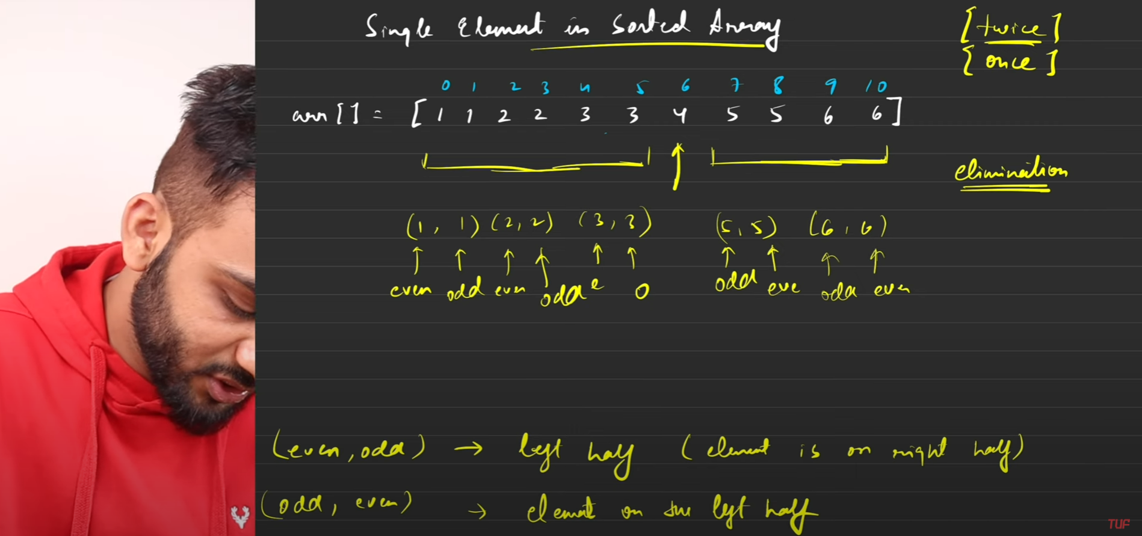

* There are edge cases if the first or the last element is the single element. Cater these edge cases separately for the main code to be clean.
* The 2 cases in the above photo at the end are the main conditions to be followed to solve this question.

**Q13)** [**Find peak element**](https://takeuforward.org/data-structure/peak-element-in-array/)

* There are edge cases if the first or the last element is the peak element. Cater these edge cases separately for the main code to be clean.
* Then check if the mid element is the peak element by checking its neighbors. If it is not then check:
* If the left side is less than the mid element then the peak element lies on the right side so we trim the left side of the array and otherwise the right side of the array.

**BS on Answers:**

**Q1)** [**Find square root of a number in log n**](https://takeuforward.org/binary-search/finding-sqrt-of-a-number-using-binary-search/)

* suppose you have to calculate square root of n.
* take range from 1 to n and search for mid.
* Check if mid*mid<=n. if true it can be the answer and look for more possible answers on the right side and otherwise trim the right side and look for the answer on the left side.

**Q2)** [**Find the Nth root of a number using binary search**](https://takeuforward.org/data-structure/nth-root-of-a-number-using-binary-search/)

* in this question you will have to calculate nth root of m.
* so just like above take a range from 1 to m and check.
* Keep multiplying mid to mid n number of times and keep performing check if it exceeds the value of m. if it does immediately trim the right side and calculate new mid.
* Also you should get an integer as the final answer otherwise return -1.

**Q3) Koko Eating Bananas**

* Koko has to eat all the bananas before guard come.
* The minimum speed can be eating 1 banana per hour and the maximum speed can be eating the number of bananas in the maximum pile.
* So we take this range and apply binary search of the mid number and see if koko eats with this speed will he be able to eat all the bananas.
* If he will be we go on the left side as on the right side the speed will be even more and he will definitely eat all the bananas so we have to find out the minimum speed by which he can finish so we reject the right half and search for on the left half.
* If he eat by mid speed and he cannot finish the bananas then its speed is too low and we see on the right side to increase the speed.

**Q4) Minimum days to make M bouquets**

* In this problem you have to make m bouquets with k adjacent flowers from a garden.
* We have to wait for a certain number of days for a flower to bloom and then only we can use it to make a bouquet.
* So the maximum of the garden array will be the day when all the flowers will be bloomed.
* So from 0 to the maximum of the array is our range.
* We check on the mid day how many flowers are bloomed and will it be sufficient to make bouquets.
* If yes then all the days to the right of the mid will also be true and since we want to get the minimum we check on the left side.
* If no then we need more days and more flowers so we check on the right side.

**Q5) Find the smallest divisor**

* We need to find the smallest divisor by which if we divide all the elements of the array and then add all the quotients we reach a value less than or equal to a certain threshold.
* The smallest divisor can be 1 and the largest can the maximum in the array.
* So this is our range and we find a mid and use that as the divisor and check if we get less than or equal to the threshold.
* If yes then all the number on the right of mid with also give the answer but we need to find the lowest so we go on the left side.
* If no then we need to increase our divisor and so we go on the right side of the range.

**Q6) Capacity to ship packages within D days**

* So in this problem we are given the weights of the packages that are to be load on the ship and a ship has a limit on the weight that it can carry. We need to load all the packages on ship in a d number of days and we can load multiple packages on one ship given it can carry that weight. We need to find out the minimum capacity of the ship so that we can load all the packages within d days.
* So the minimum amount of load needed is the maximum weighted package as if we cant load that one package alone we cant finish the task. So we take the minimum as the maximum weighted package.
* The maximum is the sum of all packages as in the worst case we may have to load all packages in one day.
* So this is our range and we need to find the mid and check if this is the minimum weight capacity of our ship then can we finish loading all packages in d days.
* If yes then we go on the left side as on the right side the weight ship can hold increases and so obviously it will be able to complete the task and we need to find out the least weight capacity of the ship. So we go on the left side.
* If no then we go on the right side as that limit is too low for the ship to carry all the packages in the given amount of days.

**Q7) Kth missing positive number**

* We are given an array which is strictly increasing and positive and sorted and an integer k. we need to find out the kth missing positive number.
* For ex : 1 4 and if k=2 then the missing numbers are 2 and 3 and so 3 is the answer.
* we take the 0th index as the low and the last index as the high.
* We calculate mid and then we also calculate the number of missing numbers with respect to the given array by subtracting.

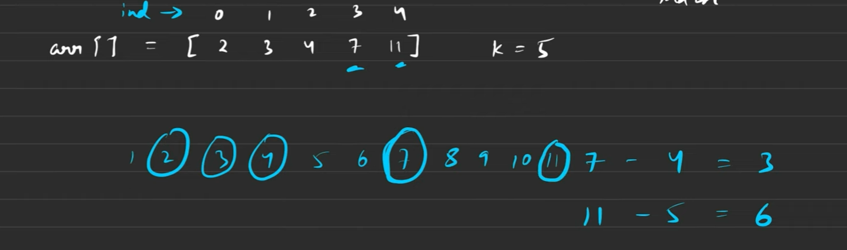

* we see that ideally 1 2 3 4 5 should had been there but now 2 3 4 7 11 are there so if we subtract them we can calculate how many missing numbers are there in between.
* Now we calculate mid and then check the number of missing numbers if it is less than the missing number we need to find out we eliminate the left half and search on the right half.
* If we get more missing number then we eliminate the right half and move the high to mid -1.
* Now in the end the high will cross the low and the high will be standing at a point which will be just one lower than the number of missing numbers you need.
* So you subtract the missing number you need to calculate by the number of missing numbers where high is standing and then add it to the arr[high] and that will be our final answer.

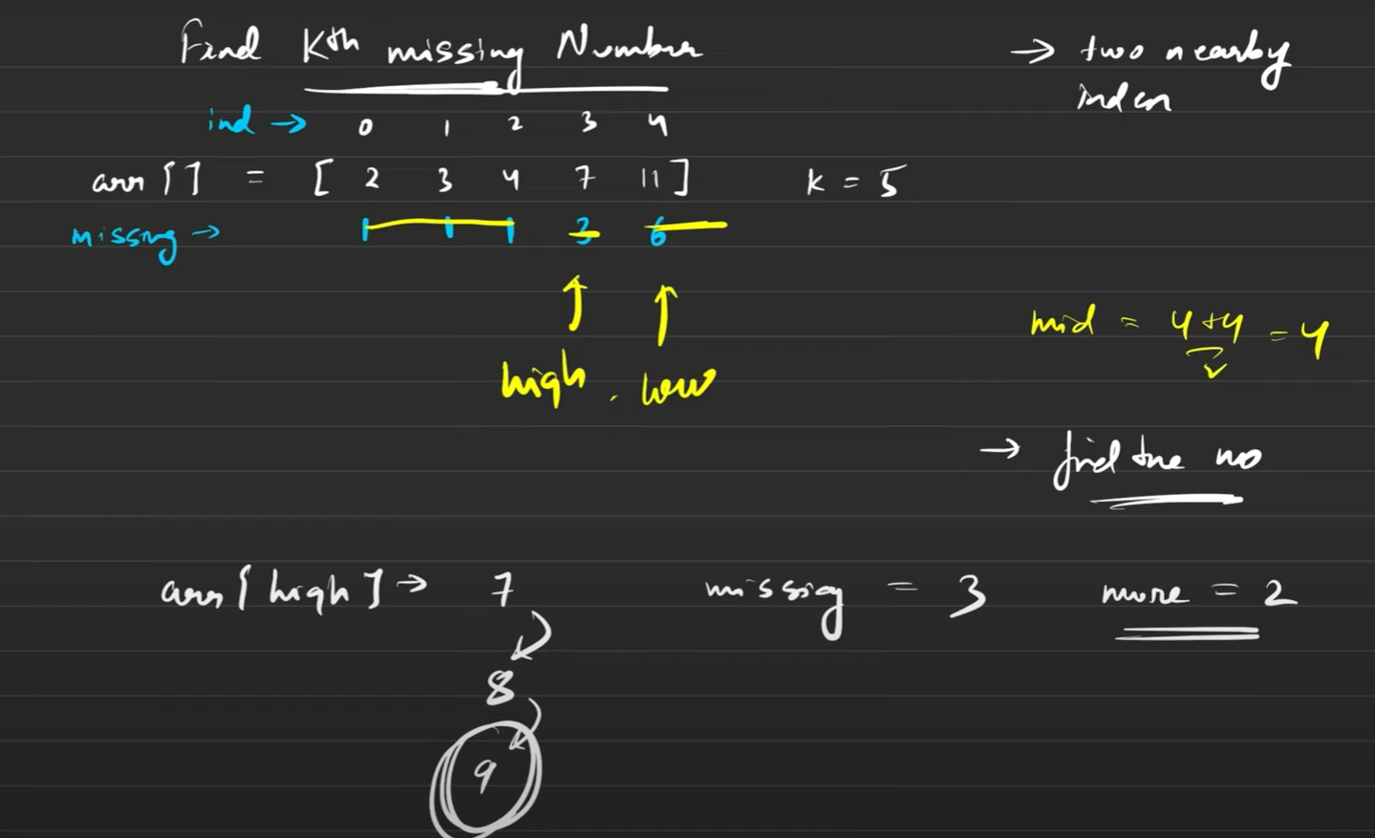

**Q8) Aggressive Cows / Magnetic Force Between two balls**

* This is a little different type of binary search problem. It is a type of **min(max)** problem.
* In this problem we are given n stables and k cows and we need to assign stalls to k cows such that the minimum distance between 2 cows is maximum.
* First of all we need to sort the stalls as we will start putting cows from the lowest stall possible.
* The minimum distance possible between two cows is 1 and the maximum distance possible between 2 cows is the difference between the minimum of the stable and the maximum of the stable.
* Now we calculate mid and check if we keep a distance of that in between 2 cows will we be able to put k number of cows in n stalls.
* If yes then we will eliminate the left half as we need to find the maximum distance between 2 cows and we will look on the right side.
* If no then we were not able to place k cows in n stables and therefore we will reduce the distance between 2 cows and therefore eliminate the right half.

**Q8) Book Allocation Problem**

* This is a little different type of binary search problem. It is a type of **max(min)** problem.
* In this problem we need to allocate books to students and each book has a given amount of pages in it. There are a total of m students and n books such that each student gets 1 book. Each book can be allotted to only one student and allocation should be in contiguous manner. We need to allocate such that maximum number of pages allocated to a student is minimum.
* So the minimum number of pages that has to be allotted is the maximum number of pages present in any book as otherwise that book cannot be given to any student which is not possible. So our lower limit is the book with maximum pages.
* The upper limit can be the sum of all the pages of all books as if there is only can student he will get all the books.
* So within this range we need to calculate our answer we will find a mid and check if that much amount of pages can be given to a student then how many books can be given to how many students like if 100 pages can be allotted to a student there are 2 books with 30 pages each and there are 2 students. However the first will take both the books and the second wont get any which is not possible.
* So we check if that many number of pages is the limit then the books are divided among how many children.
* If it is less than the number of children given then we need to reduce the number of pages each can hold so that the number of children increases and therefore we eliminate the right half and move to the left half.
* If it is more than the number of children given then we will increase the number of pages that can be hold be a student and eliminate the left half.

**Q9) Split array – largest Sum**

* **Exact same question as book allocation problem same approach exact same code.**

**Q10) Painters Partition**

* **Exact same question as book allocation problem same approach exact same code.**

**Q11) Minimize Max distance to gas station**

* We are given coordinates of n gas stations in sorted order. We have to place k gas stations in between while minimizing the maximum distance between 2 gas stations. We can put at decimal places as well.
* Solve this question using priority queue as with binary search it is very hard.
* You have to keep low at 0 and high at the maximum difference between 2 consecutive elements of the array.
* Then we calculate mid and see if that distance is kept between 2 numbers then how many gas stations can be put.
* If it is greater than the number we have then we need to reduce it and therefore increase the distance and therefore we eliminate the left half and move to the right half.
* If we can put those many gas stations as is needed then we will try to minimize the distance and therefore eliminate the right half and move to the left half.
* It is a very tricky question and will barely be asked.

**Q12) Median of 2 sorted arrays**

* This question can be done by 3 approaches.
* **1st approach : using bruteforce**
* In this approach you create a new vector and insert the data of both the vector in this new vector in sorted fashion and then check the median and directly return it.
* **2nd approach : optimizing bruteforce**
* In this approach we check the total number of elements after adding total of both the vectors.
* Suppose we have 10 elements so the median will be avg of 5th and 6th element. So we keep a count and check what will be the 5th and the 6th element and for odd case just one median element and then return it.
* **3rd approach : binary search**

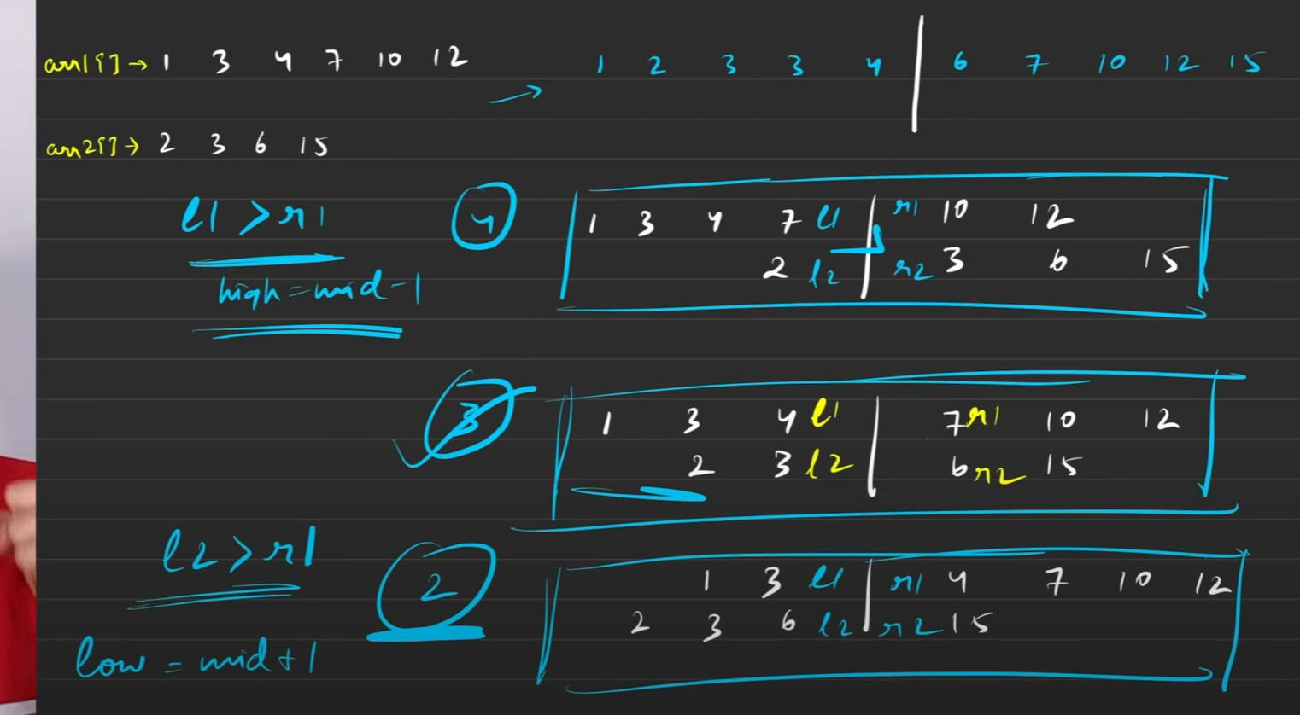

* In this method we check how many elements from the minimum elements containing array do we need to take so that if we take the rest from the other array we will have the left sorted half of the whole array.
* So we can choose from 0 to maximum number of elements in that array, that will be our range to apply binary search and the above conditions will make sure we have to eliminate the left half or the right half.
* The condition we check is of the cross elements. We check that left elements are smaller than the right elements in cross fashion for ex: l1 < r2 and l2 < r1. We need to check both of these conditions and depending on these conditions we eliminate any one half.

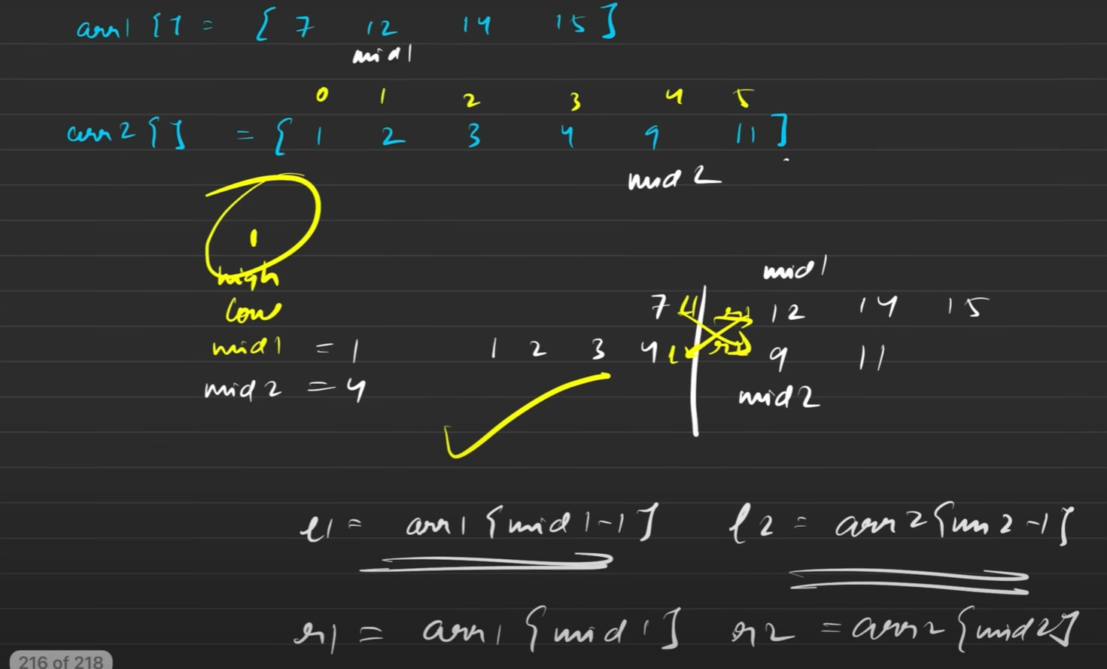



* **This is if total number of elements in both arrays sums to even.**
* **For odd elements:**

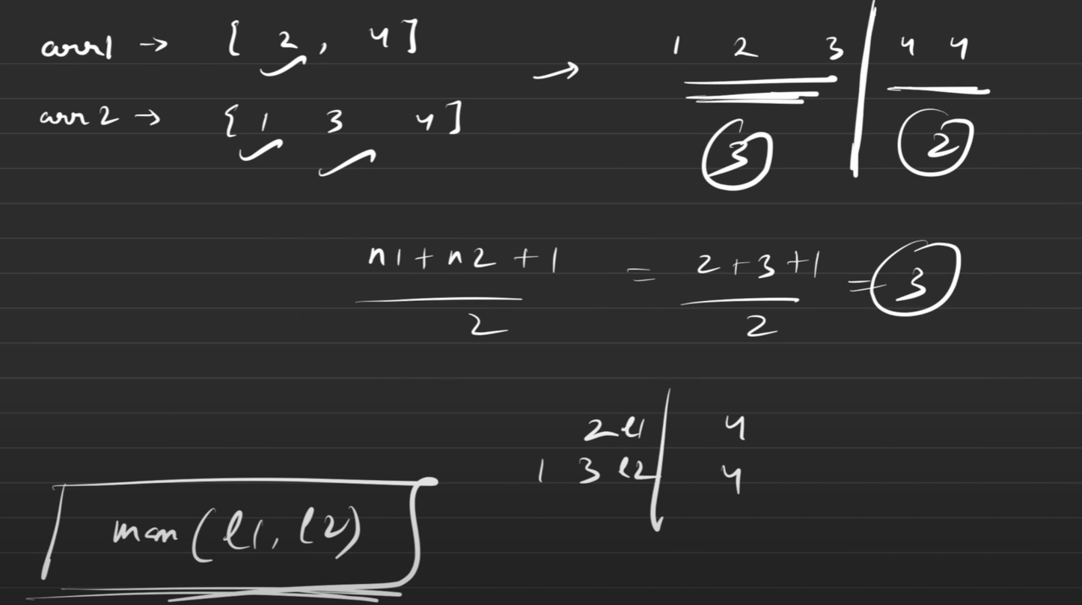

**Q13) Kth element of 2 sorted arrays**

* This problem is an extension of the last problem
* In the last problem we were trying to find the median and therefore symmetrically breaking the joined array.
* In this problem we have to find the kth element of the 2 sorted arrays and therefore we will take k elements on the left and (n1+n2) – k elements on the right.
* We have to apply binary search to see how many elements we have to take from the 1st array and remaining from the 2nd array so that we have k elements as the sorted half of the combined array.
* In this problem low will not always be 0 as it can happen that value of k is greater than the size of any 1 of the arrays. Then it is not possible that we take no elements from that array. Therefore low is set as max(0, k-n2) where n2 is the array with greater size as if it is exhausted completely then we have no option but to take elements from this array and so it cannot be 0.
* The high will also not be the size of the array with minimum element as we need only k elements on the left side so it can be the min(k, n1) where n1 is the array with smaller size.
* Then we will apply binary search on this range and check that same way of cross checking the elements l1 l2 r1 and r2 and in the end we will only return the max(l1, l2) as our final answer.

**BS on 2D arrays:**

**Q1) Find the row with maximum number of 1’s**

* In this problem we need to return the minimum row number with maximum number of 1’s.
* We will iterate on each row and calculate lower bound of 1 and use it to get the number of 1’s in that row.
* Then we calculate the maximum and return its minimum index.

**Q2) Search in a 2D matrix:**

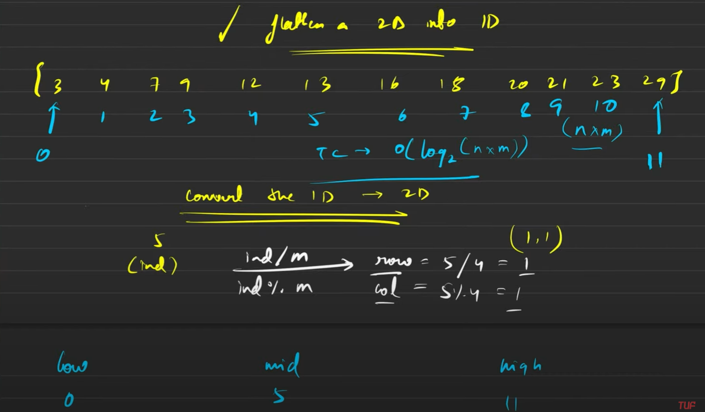

* in this problem we need to search for a target in 2d matrix and we need to solve this question in O(log(m*n)) so we need to use binary search.
* So we will flatten the 2d array in 1d array and use formula of row= mid/m and col=mid%m to convert values to row and column and then check like normal binary search problem.

**Q3) Search in a 2D matrix – II**

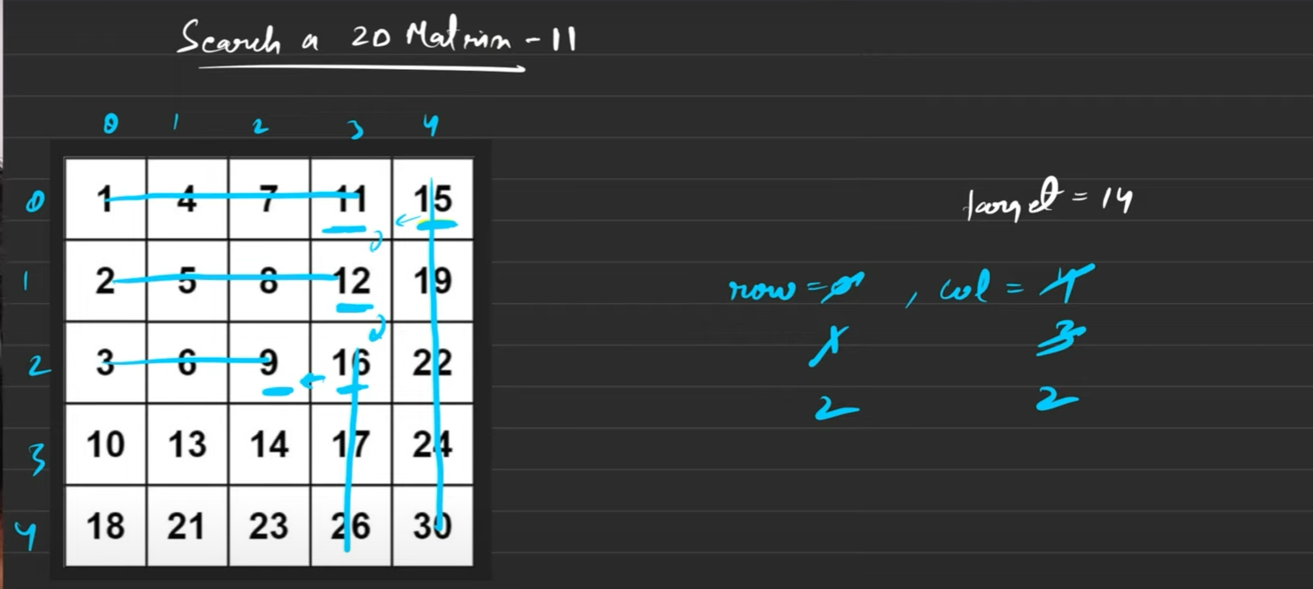

* In this problem we need to find out the target in a 2d matrix which is sorted both row wise and column wise.
* We will stand at the top right corner and eliminate either that row or the column and move accordingly.

**Q4) Find peak element (2d matrix)**

* In this problem we are given a 2d matrix and we need to calculate the peak element i.e. which is greater than all 4 of its neighbors.
* In this problem we will use binary search as we will go on the first row and calculate mid where low is 0 and high is the number of columns in the matrix.
* Once we get the mid we will check the maximum element in the mid column is present in which row using another function. This function will return the row number which has maximum element and then since it is maximum in that column we will only have to check for the left and right side.
* Make sure you take care of the edge cases where element can go out of the boundary of the matrix.
* If it is greater than all 4 return it.
* If the left is greater than that number then we eliminate the right half and then again check mid and max element in that column and repeat the process.
* If the right is greater then we eliminate the left half.

**Q5) Matrix Median**

* In this problem we are given a matrix in which all rows are sorted. We need to calculate the median of this 2d matrix.
* We will use binary search to solve this question.
* We will take low as the lowest element in the first column and the highest element as the highest element in the last column as this is our range in which we apply binary search.
* We calculate mid and then check how many numbers are less than equal to the mid value in the matrix.
* For this we traverse to each row and then calculate the upper bound of mid in that row. This gives us the value of number of elements less than mid in that row.
* We sum that up and return it to the binary search function.
* If that value comes up less than equal to mid then we need to increase its value and so we eliminate the left half and move to the right half.
* If that value comes up greater than mid then we need to reduce its value and so we eliminate the right half and move to the left half.

**Strings:**

**Basic and Easy String Problems:**

**Q1) Remove Outermost Parenthesis**

* In this problem we are given a string of parenthesis and we need to return the inner most parenthesis deleting the outermost ones.
* For ex: (()()) if this is given then we need to return ()().
* So to solve this question we create a stack and push the element if the stack is empty and continue.
* If the stack gets ( then it will push back it in the stack and answer string.
* If the stack gets ) then it will pop it from stack and if size of stack is greater than 1 then push the element in answer string. Then return the string.

**Q2) Reverse words in a given string / palindrome check**

* In this problem we have a reverse a complete string which can have multiple spaces in between or starting or end.
* We need to reverse such that the last word becomes the first word and so on.
* So to solve this question we will create two strings, one to store our word and second the answer in which we will keep adding the words from temp to formulate our answer.
* So we will traverse on our string.
* First we will check if it is not a space if not then we will keep adding it to temp till a space is reached. Then we will check if temp has something in it as this will ignore all extra spaces.
* Now we will check if the ans is completely empty and it is the first word as then we will only put the temp directly to answer (**ans = temp)**.
* Otherwise if ans is not empty then we will put a space between the already existing data of ans and temp as (**ans = temp + “ “ + ans).**
* Then we will check in the end if temp is empty or not as if there is no trailing spaces then the last word of the original string will be placed in the temp and so we empty temp by checking condition if it is empty or not and also we put it in ans depending on the above 2 conditions as we can have only one word in string with no trailing spaces. So this way all cases are covered and then we return the value of ans.

**Q3) Largest odd number in a string:**

* In this problem you are given a string with a number and you have to return the largest odd number that is a substring of the original string.
* To solve this question we can either declare an end pointer and move it to left if we get an even digit and then when we get an odd we immediately return from 0 to that pointer +1 location.
* Other way can be we can see the back of the string using the function **num.back()** and then check if it is even if it is then we use **num.pop_back()** and we continue this till we get an odd value when we return the whole num then.

**Q4) Longest Common Prefix**

* In this problem we have to find the longest common prefix. We are given a vector of strings and we need to find the longest common prefix.
* So we first sort the vector so that we can have the most different two strings at the beginning and end of the vector.
* Then we compare these two strings for each place by running a loop for whichever string is smaller number of times and then the moment we get a different character we break out of the loop otherwise we keep adding the common prefix in the answer variable and then return that ans.

**Q5) Isomorphic string:**

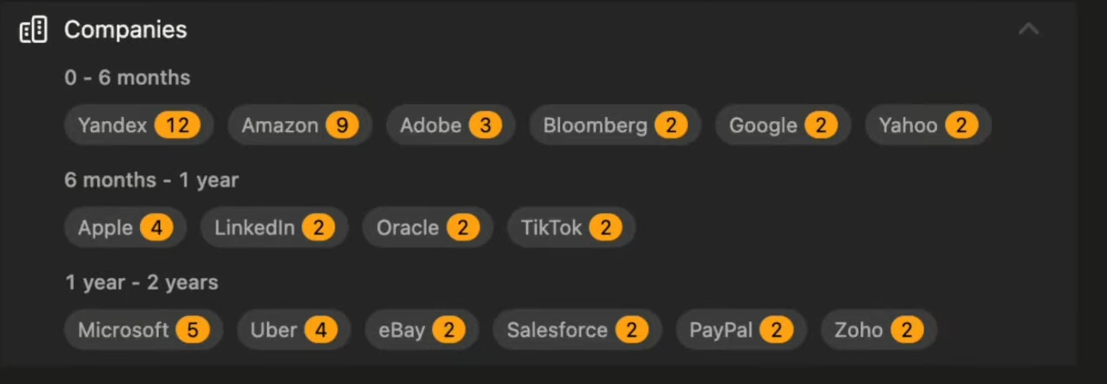

* This is somewhat better question than before.
* In this question we need to check isomorphic strings. **Two strings s and t are isomorphic if the characters in s can be replaced to get t.**
* For ex: **egg add** are isomorphic, **paper title** are isomorphic but **foo bar** are not isomorphic.
* So to solve this question we create 2 hashmaps, one to make relation of one character to the other character and so that if like a is connected to b then whenever a appears in the 1st string b should appear in the second string. To make this sure we create hashmap and store this relation and everytime a we check if this character is already in hashmap then is it correctly related in both strings.
* But there is one more condition that no 2 elements can relate to 1 element meaning that it cant happen that a points to b and d also points to b.
* To make sure this doesn’t happens we create another hashmap in which whenever we make a relation we put the value being related to as used up in the hashmap so that the same value is not taken by any other character as well.

**Q6) check whether one string is rotation of another**

* This is a relative easy question.
* In this question we have a main string and a goal string we need to return that whether left rotating main string can become the goal string.
* You can left rotate string one spot at a time and check if it is now equal to the goal string. If yes return true. Else false.
* Another method can be you add goal twice to itself and then search for the main string inside the goal string. If the answer is true it will lie in the goal state.

**Q7) Check if two strings are anagram of each other:**

* This is also an easy problem.
* **An Anagram is a word or phrase formed by rearranging the letters of a different word or phrase, typically using all the original letters exactly once.**
* So we can create either a hashmap to keep a count of the frequency or we can create an array of size 26 for this task and then we increase frequency by 1 for the string s and decrease frequency by 1 for string t.
* If at the end all map elements have 0 as the value stored for every key then it is true else false.
* Same goes for the array as well.

**Medium String Problems:**

**Q1) Sort characters by frequency:**



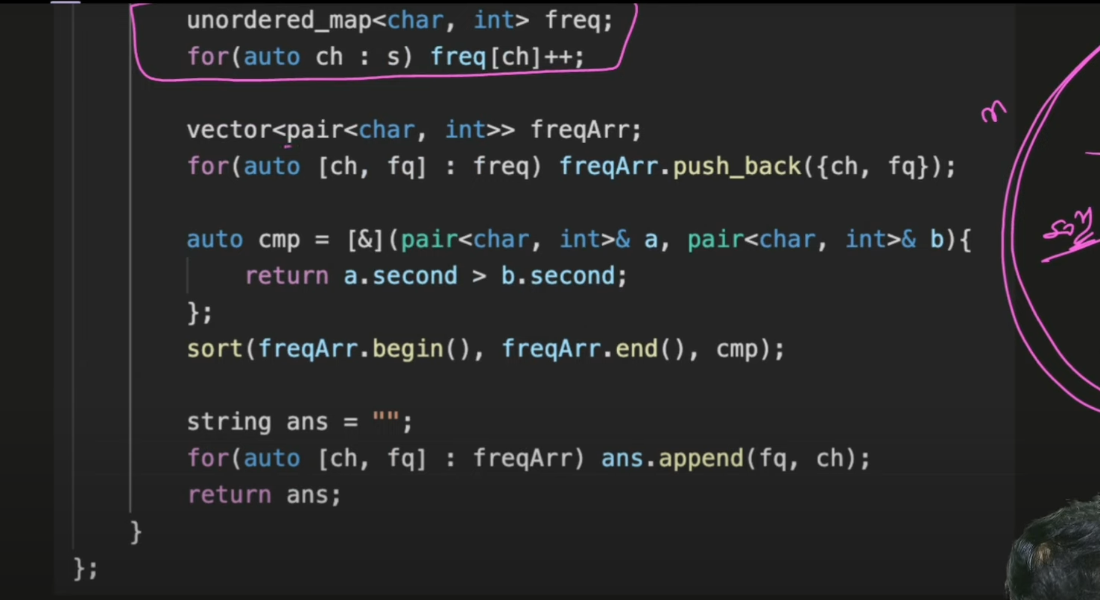

This is how you use hashmap with auto keyword (Hashmap auto)

* This is a hard and important question. In this question we learn a lot of new things which are how to sort depending on our own compare function or how to use vector and unordered map with auto keywords nicely.
* So in this question we had to sort characters by freq i.e for ex: tree becomes eert or eetr, Aabb becomes bbaA or bbAa etc.
* We need to sort depending upon frequency.
* So we create an unordered map and put all the characters and their frequency in the map then we create a vector of pair and put everything from unordered map to vector and then sort this vector depending on the frequency or the second value.
* To do that we had to write our own compare function for sort function as shown. Then we traverse on this sorted vector of pairs and then append into ans string that character freq number of times and therefore we get our answer.

**Q2) Maximum Nesting Depth of Parenthesis:**

* This is an easy problem. We need to return the maximum depth of parenthesis.
* So we traverse the string and if we encounter a ‘(‘ we add in a count variable and if we encounter ‘)’ then we subtract and at each step we keep the max of count in another variable ans to keep the maxima count and in the end return ans.

**Q3) Roman Number to Integer and Vice Versa**

* This is a moderate question. We check for the roman numbers like I, X and C which can appear in front and at the back of other letters and solve them separately and then we write the rest to add up the sum as expected. See the answer on leetcode for this question it is simple.

**Q3) part 2 Reverse of above problem:**

* In this last problem we converted from roman to integer and in this we will convert from integer to roman.
* So we create a vector of pair of int and string and store all possible combinations in it in descending order starting from M, CM , CD, all the way to I.
* We iterate in a loop and divide the given number by each possible combination to get the quotient and we add whatever quotient we get that many times that character to our final string and keep reducing the number.
* We finally return the string so formed.

**Q4) Implement Atoi**

* This is an average level question of string.
* In this question you are given a string and you need to convert it into an integer till possible. If and alphabets or special symbols appear you have to return the number possible before it.
* Also you need to take care of – and + sign as they can be present and also the blank space present in the starting of the string but if there is any blank space in the middle you have to break right there and return the number below it.
* So we take care of leading spaces by the substring function and each time we get a space we check if It is 0th index and if yes then we skip it using substring function.
* To take care of negative sign we keep a flag which turns true if – sign is encountered and then checked at the end.
* If + sign is encountered we ignore it.
* In the end if the ans is outside the range of INT_MAX then we return INT_MAX if – sign wasn’t there otherwise we return INT_MIN.

**Q5) Count Number of Substrings:**

* This is also a hard problem in which we need to count substrings with k distinct characters.
* See the solution of this question on GFG as it is hard.
* In this solution instead of finding exact equal to k we find atleast distinct k and atleast distinct k+1 and then we subtract those both.
* To calculate atleast k or k+1 we write a function which returns the count of atleast k distinct characters.

**Q6) Longest Palindromic Substring:**



* This problem can be solved by many methods.
* The extreme bruteforce would be to to calculate all substrings and check if it is palindrome which will take O(n3) .
* If we use memorization of DP then we can reduce the time complexity to O(n2) but with extra space complexity of O(n).
* If we use two pointer approach we can solve it in O(n2) time complexity and with O(1) space complexity. This is the approach we need to tell in interview. View the question on leetcode it is solved by this method only.
* Last method is **Manacher**’s **algorithm** which can solve this question is O(n) time complexity.

**Q7) Sum of Beauty of all substring**

* Beauty is the difference of the highest frequent character and the lowest frequent character.
* In this problem you are given a string. Calculate the beauty of all substrings and return sum of it.
* So we use 2 loops to get all substrings and then write a beauty function which returns the beauty value of the current substring and add it to the ans variable and in the end return this value.

**Q8) Reverse Every Word in a String:**

* This is the same problem as string basic Q2.

**Linked List**

**Learn 1D linked List**

**Q1) Introduction to LinkedList, learn about struct, and how is node represented**

* Just create a head and insert the first element in it.
* Then create a temp to move along the linked list as we cant move with head otherwise head will be lost.
* So we move using temp and in the loop we create new nodes and insert them after temp.
* Return head at the end.

**Q2) Inserting a node in LinkedList**

* You can be asked to insert a node at the beginning of the linked list or at the end of the linked list.
* If inserting at head then we create a node and put the original head in its next and return this new node.
* If inserting at rear then we first check if already given head is NULL.
* If it is null we just create a node and return it.
* If it is not null then we iterate on the linked list using a temp variable and then insert a new node with the given value at the end of the linked list.

**Q3) Deleting a node in linkedlist:**

* You need to delete a node in a linked list and you are directly given that node itself not the head of the linked list.
* So we copy the value of the next node in this node and then set pointers such that we delete the next node present in the linked list and since it is given it is not the last node of the linked list it will always work.

**Q4) Find the length of the linked list (learn traversal)**

* In this problem we need to return the count of the linked list how many elements are present in the linked list.
* Just traverse on the linked list and increase count by 1 everytime and return count+1 in the end.

**Q5) Search an element in the Linked List:**

* You need to find whether an element is present in the linked list or not.
* Just traverse on the linked list and if the value is there return true else return false.

**Learn Doubly LinkedList:**

**Q1) Introduction to DLL, learn about struct, and how is node represented**

* Create a head and put its previous equal to NULL.
* Then create a temp pointer equal to head.
* Then create a newNode and put its previous to temp and put temp next to this new node and then move temp by one.
* Repeat this till all elements of array are exhausted.

**Q2) Insert a node in DLL**

* In this problem we have to insert a newNode with a given data at a particular position.
* We just have to check whether it is the last element to be added or in the middle as both will have different ways of balancing the pointers.
* Just balance the pointers as shown in the gfg code and it is done.

**Q3) Delete a node in DLL**

* In this problem you have to delete a node from a DLL.
* There can be 3 cases deleting the first node, last node or in middle.
* See the solution at gfg for balancing all cases correctly and return head at the end of each case.

**Q4) Reverse a Doubly Linked List**

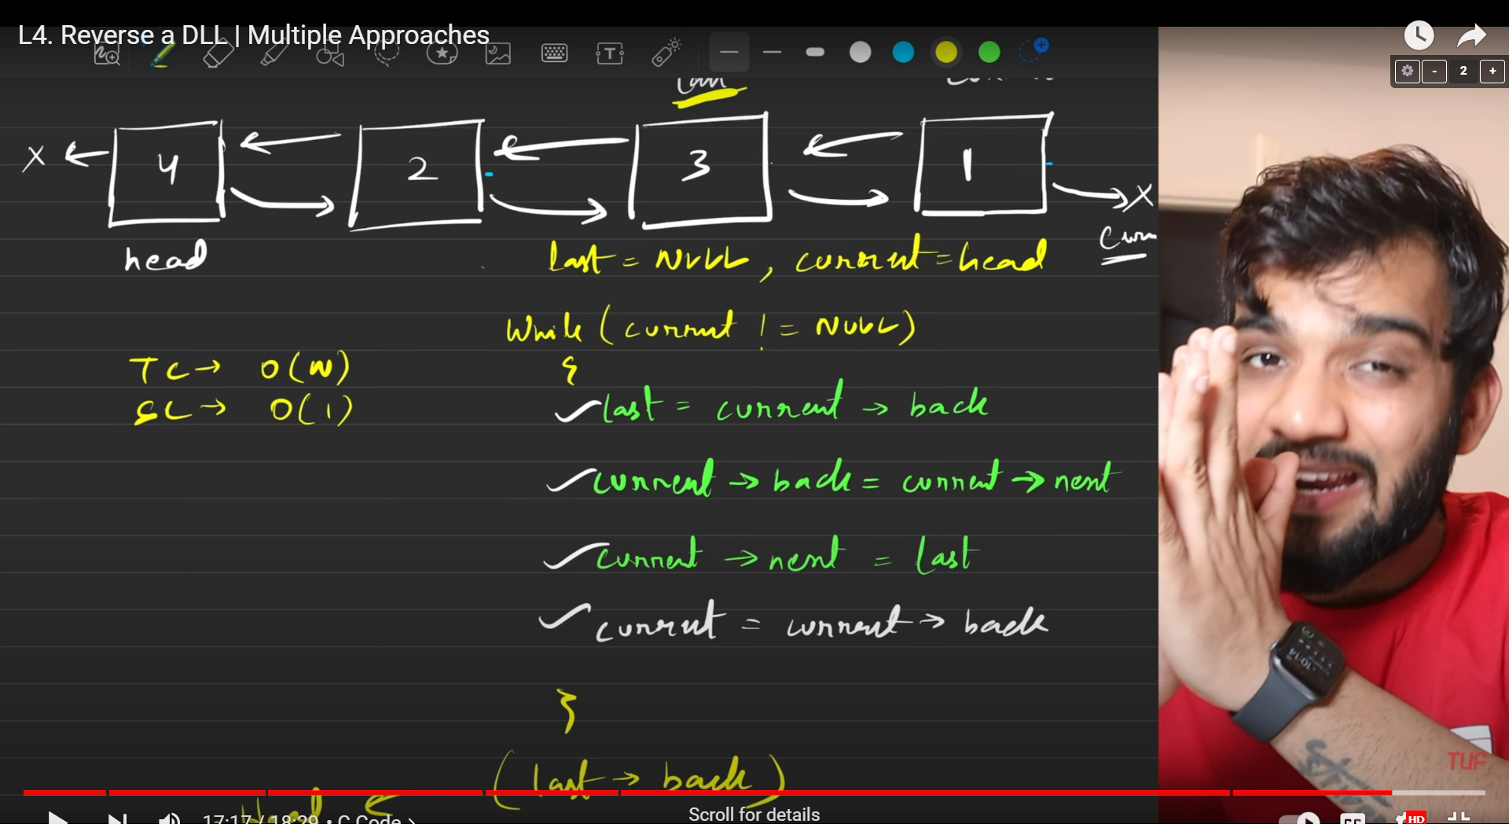

* In this we use the concept of swapping two numbers using a temp pointer.
* The same way we will swap the next and prev pointers using a temp pointer.

**Medium Problems of LL**

**Q1) Middle of a Linked List**

* You have to solve this problem using tortoise and hare method.
* Create a slow and fast pointer both equal to head.
* Move slow by 1 and fast by 2 and make sure fast is not equal to NULL or its next is not equal to NULL. Till then keep repeating this. In the end slow will be pointing to the middle of the linked list.

**Q2) Reverse Linked List (Iterative)**

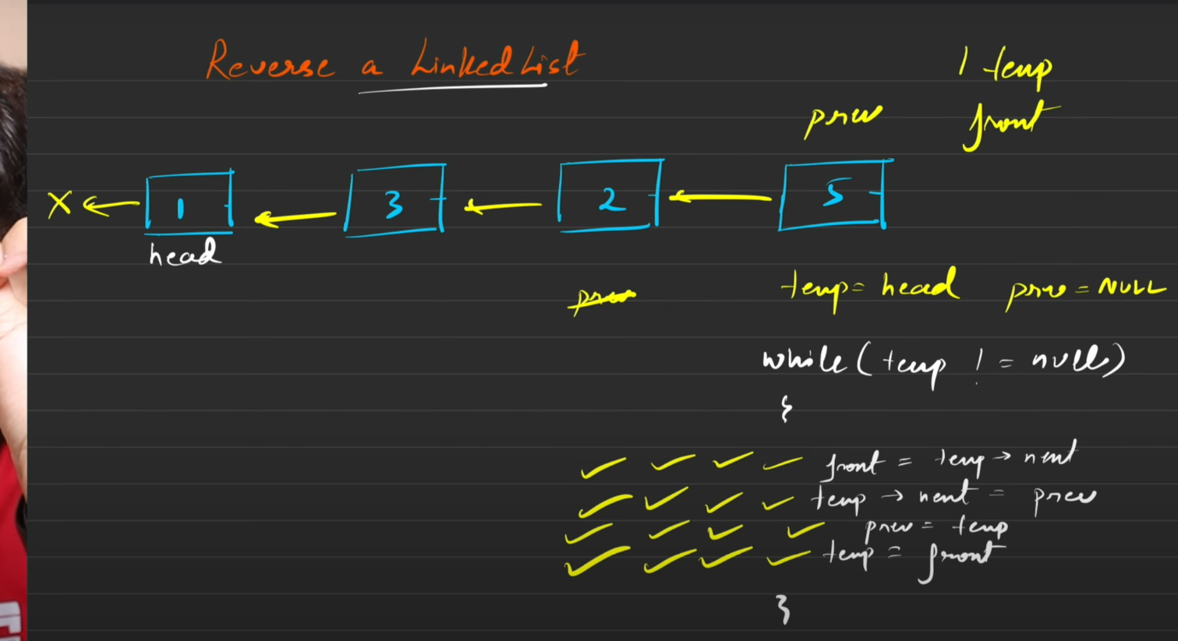

* This is one way or reversing the linked list.
* In this we keep 3 pointers prev curr and forward at NULL, head and head->next and then we arrange the pointers as shown above.

**Q3) Reverse Linked List(Recursive)**

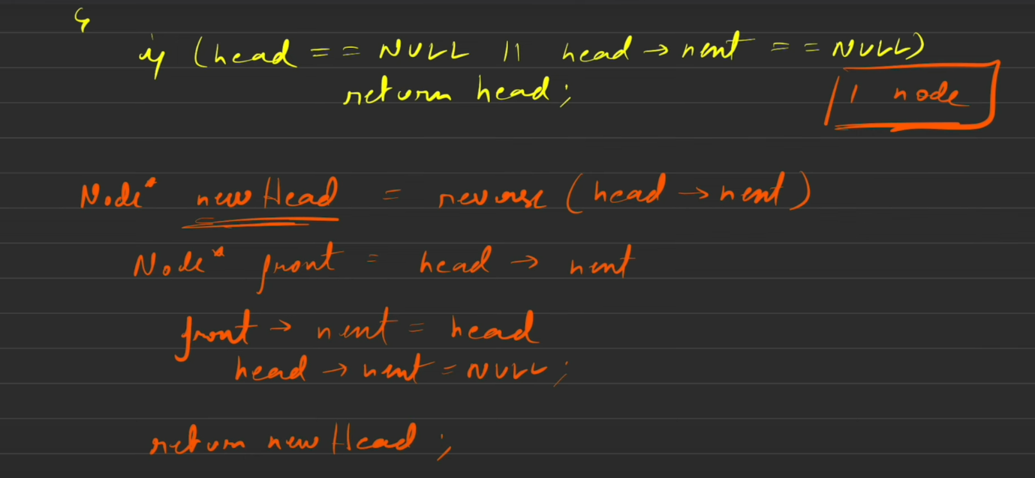

* To reverse a linked list using recursive approach we need to write a base case where head is either NULL or there is only one size linked list which we will return as it is.
* Then we send the smaller problem in the recursion such that we reach the last element.
* There we change the links as

head->next->next=head; and

head->next=null;

* These two are the main conditions to change our links and then return the new head.

**Q4) Detect a loop in LL**

* This question is done using the tortoise and the hare method.
* We move slow by 1 and fast by 2 and if there is a loop in the linked list then they both will be equal at a given point.
* Otherwise the loop traversal will end with the condition on the hare movement.

**Q5) Finding starting point of cycle in LL**

**Proof that they will collide and at starting point.**

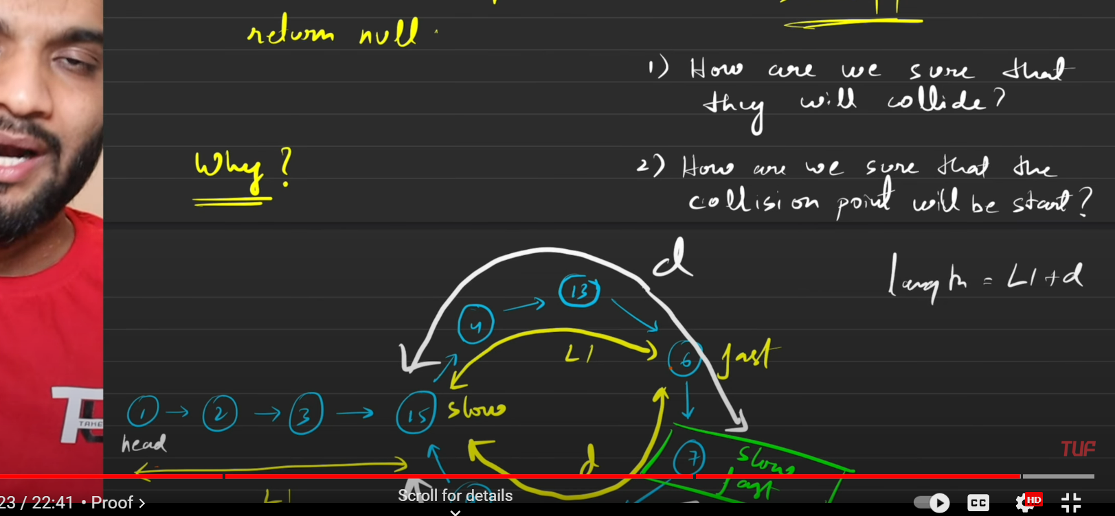

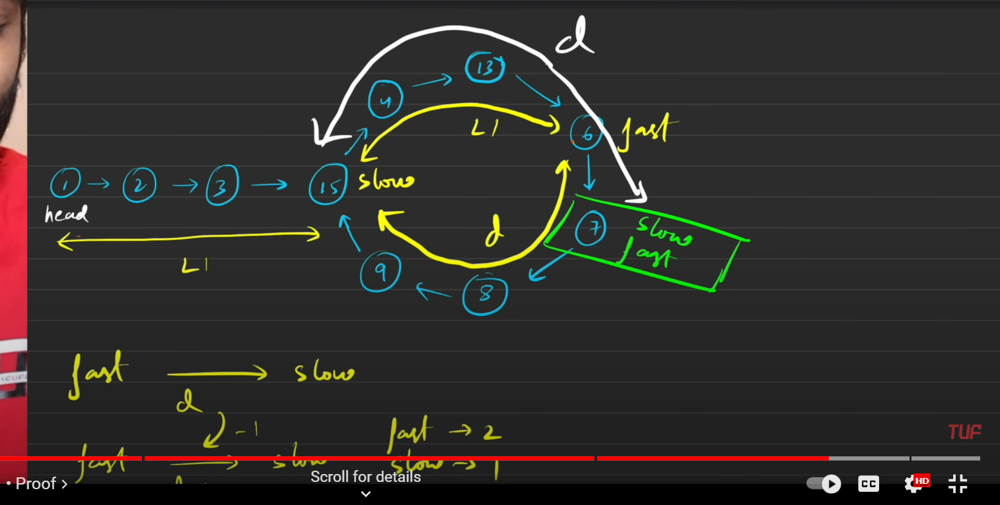

* So in this problem we have to detect if there exists a cycle and if a cycle does exists then at which point the cycle is starting.
* To solve this problem we use the tortoise and the hare method. We move slow by 1 and fast by 2 and then keep moving them till either fast is at null or its next is null signifying there is no cycle in the linked list.
* But it they collide then we start slow again from head and this time we move both by 1 place at a time and this time they will collide at the point of intersection only.
* The prove they will collide there only is that
  + Suppose they both started moving and slow has moved L1 space. Then fast would have move 2L1 space.
  + Now suppose the total loop is L1+d length. Slow is moving with 1 speed less than fast and therefore they will collide for sure. When the slow and fast will collide for the first time the fast would have moved by 2d and slow would have moved by another d distance.
  + Now from the initial point of the loop slow moved d distance and therefore L1 distance is left in the loop and since now we start slow again from head the distance from head to the loop starting point is also L1 and therefore they both will collide for sure.

**Q6) Length of Loop in LL**

* This problem is also solved using tortoise and hare method. In this problem we first check if there is loop present or not in the given linked list using tortoise and hare method.
* If slow and fast are at the same position then loop does exists and therefore, we need to calculate the number of elements in this loop.
* So we will fix the slow or high pointer at that collision point and move the other one step at a time increasing count variable from one and when that pointer reaches the collision point again count will contain the size of the loop and we return it.
* If there is no loop present then we return 0.

**Q7) LL Palindrome**

* To solve this question first we need to find the middle element that too if even numbers then see the left middle element.
* For this we use hare and tortoise method.
* Then we reverse the linked list after that middle element and then check from the front of that middle zone and starting of the LL are all elements in same order.
* If no then it is not a palindrome and we reverse the LL again to retain back the original list and then return false.
* If yes then it is a palindrome and we reverse the LL again to get back the original list and then return true.

**Q8) Segregate odd and even nodes in LL**

* In this problem we have to club all the odd nodes of the linked list together and the even nodes together and place all even nodes after the odd nodes.
* We create 4 pointers of odd_head, even_head, odd_temp and even_temp.
* We move temp of odd and even for the conditions they do not lie outside.
* Then we club all odd together with odd_temp and even together with even_temp and then we place odd_temp -> next = even_head. And then we return odd_head as our final answer.

**Q9) Remove Nth Node from the End of List**

* So in this problem we need to remove nth node from the end.
* So we can do this by calculating the length by one traversal and then count-n will be the number of nodes you need to skip from the front.(**Bruteforce)**
* Another approach can be the number of nth node from the end. You start slow from head and fast from head and then move fast to n nodes in front without moving slow and then move both of them together by one step.
* When the fast->next reaches null the slow will point to one node before which has to be deleted and if fast is equal to null then it means you have to delete the head node and therefore such conditions and links are made.

**Q10) Delete the middle Node of a linked list**

* In this problem we have to solve using tortoise and hare algorithm.
* We start slow at head and fast at

head->next and move both by 1 and 2 steps till fast!=NULL and fast->next!=NULL and fast->next->next!=NULL as this takes care of both even and odd cases of the middle element.

* To delete an element we simply change the links of the linked list and deallocate the space.
* If the linked list contains one element then we have to delete the one element and return NULL.

**Q11) Sort LL**

* In this problem we have to sort the given Linked list.
* We will use merge sort to perform the sorting.
* To use merge sort we will divide the linked list in two halves and keep on diving it till we have 1 element each and then we will join them according to their values and then keep rejoining it till we get our whole linked list back.

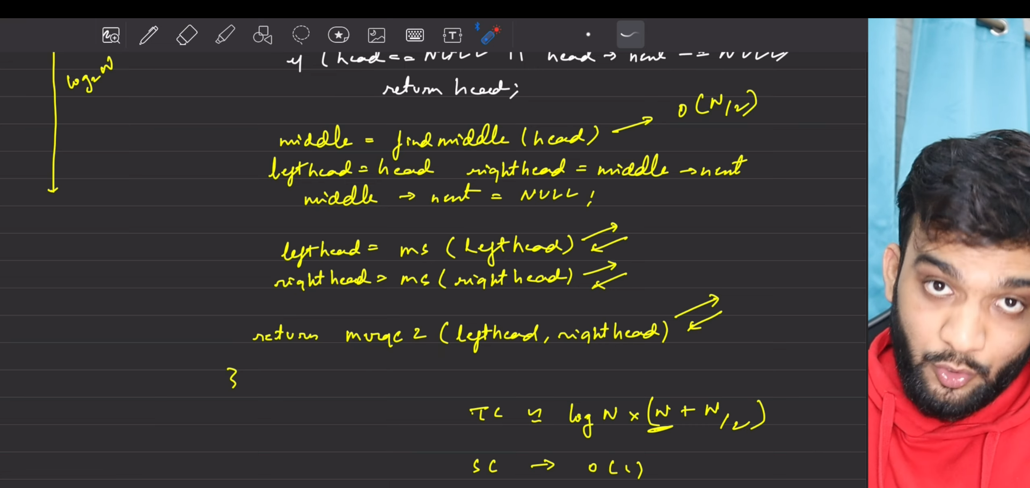

* Now we will divide the linked list as shown above.
* Now we will create merge function to merge 2 sorted list.
* In this function we will create a dummyList = -1 and then we traverse in head 1 and head2 using temp pointers and arrange in the dummyList in sorted order and in the end we return dummyList->next.
* By the combination of these 2 we can easily sort a given linked list.

**Q12) Sort a LL of 0’s, 1’s and 2’s by changing links.**



* In this problem we only have 0’s, 1’s and 2’s as node values in LL.
* So we create 6 pointers that are zeroHead and zeroTemp, oneHead and oneTemp and twoHead and twoTemp.
* Then we traverse the main linked list and divide them in these 3 linked lists.
* Then we join them using these conditions:

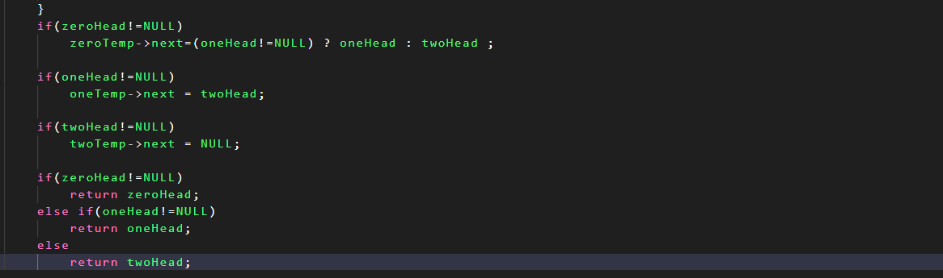

**Q13) Find the intersection point of Y LL**

* This problem can be solved by 3 methods.
* You have to determine the first node at which both LL intersect. If they do not return NULL.
* In the first approach we need to use Hashmap and store all nodes of any one LL in the hashmap and then traverse the second LL trying to search if same node Is present as on the hashmap.
* If yes then return that node otherwise return NULL.
* In second approach we need to calculate length of both LL and then move the larger one with the difference so that they both stand at the same length from the intersection or NULL.
* Then we move both of them together one step at a time and when both are equal that is when we return the node or NULL value.
* In the 3rd approach we keep 2 pointers t1 and t2 at head 1 and head2. When t1 reaches NULL we change it to head2 and when t2 reaches null we keep it at t1. This puts both of them at same vertical level from the intersection or NULL.
* This goes on till t1!=t2 and if(t1==t2) then we return t1.

**Q14) Add 1 to a number represented by LinkedList**

* This problem can be solved by 2 methods.
* You are given a linked list in which you have to add 1 at the last node and then carry on the carry generated to their previous node. One way can be to reverse the array in the beginning and then add 1 to the first number and then carry on that 1 forward and if it is carried on till end then add a new node with the value of that carry.
* Then again reverse the node and return it as your answer.
* Another approach can be to use recursion. By recursion we reach the last node and then we calculate carry by the helper function.
* We start with carry equal to 1 as we have to add 1 to the last number and then after adding 1 we calculate the new carry and then return it.
* This goes on and if a carry is returned at the end we create a new node and then make it as our new head otherwise we just return original head.

**Q15) Add 2 numbers in LL**







* In this problem we are given 2 linked list and we have to add these two linked lists and create a new linked list that will hold the sum of the above 2 linked lists.
* You have to take care of the carry as well and carry goes from left to right and also the size of both linked lists can be different.
* So we traverse both till either of them is NULL and till then add both values with carry and make a new node of that value and store it.
* We then calculate the next carry.
* This keeps on going till either 1 LL finishes.
* Then we check if there are any more elements left in any one of the LL and add only carry to it.
* Then atlast when all are finished we check if carry is greater than 0 as then we give carry another separate node.
* Then we return head of this addition LL.

**Medium Problems of DLL**

**Q1) Delete all occurrence of a key in DLL:**

* In this problem we have to delete all occurrence of the target from the DLL.
* So, we traverse on the DLL using temp and keep the 3 cases on mind if the head is target if the tail is target and if the target is in between.
* We keep deleting the element and change to links as per required see the solution on CN or GFG.

**Q2) Find pairs with given sum in DLL:**

* We will place a left pointer at the start and a right pointer at the end of the DLL.
* Now we add left and right and check if sum is equal to target if it is we store that pair otherwise if sum is greater than target then we move right to prev and otherwise left to next.
* Keep doing this till left->data < right->data.

**Q3) Remove duplicates from sorted DLL:**

* In this question we are given sorted DLL with duplicate elements. We need to remove all duplicate elements.
* So we traverse on the DLL with temp1 and keep a condition that temp1 should not be NULL. Then we take temp2 equal to temp1->next and then we check values of temp1 and temp2 given that temp2 is not null.
* If they are same we deallocate this memory and move temp2 one place forward and we keep doing this till we find a new element when we join temp1 with temp2 and then move temp1 to temp1->next.
* This keeps on happening and while setting the prev connection we have to make sure that temp2 !=NULL as if we have 4 as the last element and 4 appears more than 1 times then that can cause error and therefore we need to check a condition here as well.

**Hard Problems of LL**

**Q1) Reverse LL in group of given size K**

* In this problem we need to reverse LL in group size of k and return the new head.
* We will create 4 pointers to solve this problem.
* Temp, kthNode, prevNode, nextNode.
* While temp is not NULL we will run the loop in which we calculate the kthnode we need to reverse till as we will separate it from the given linked list and then reverse it.
* if kth node is NULL this means the length of the LL is small than the group size k and so we check if prevNode!=NULL as if it is equal to NULL there was no previous group that we reversed and so the whole length of this LL was less than the group size k.
* if prevNode !=NULL then these are the last elements of the LL whose size is less than group size and so without reversing them we just add them after the prevNode.
* To do that we will split after kth node and before splitting we will save the next in the nextNode.
* Then we reverse the group of k and the temp is still stored at head but newhead would be returned by kth node and so if head==temp then we put head = kthnode as the main head of this linkedlist.
* Then we set prevNode as temp and then move temp to nextNode.
* If temp!=head we had originally set to prevNode to temp which was at the starting of a new group but when we reverse that linkedlist the prevNode automatically reaches the end of the linked list and to join the new group and old group we write prevNode->next=kthNode.
* Follow all these conditions and the LL will be reversed in k group size.

**Q2) Rotate a LL**

* In this problem we are given a k value and we need to right rotate a given linked list k times.
* To solve this question we go to the end of the linkedlist using tail pointer and join the last node to the front node to make it a cycle.
* While traversing you can also calculate the length of the LL and then len-k times move tail to the front and detach the linkedlist at that point and the next of that detach point is our new head.
* Also you can divide k by length and take its remainder as the new k as if k is 10 and length if 6 no point of doing it 10 times as it will be same as doing It 4 times.

**Q3) Flattening of LL**

* In this problem we are given a weird type of linkedlist which have next as well as bottom pointer where each node has a next and a bottom pointer which is another sorted linked list in its own.
* We have to return only 1 linked list with no next and only all bottom pointers which are ordered in bottom fashion.
* To solve this question we use the concept of recursion and merging of 2 sorted linked list.
* We will keep merging the last two node of the linked list and return the new head till we get only 1 head left and then we finally return that head as well.

**Q4) Clone a Linked List with random and next pointer:**

* In this problem we are given a linked list in which each nodes have 2 pointers, one next and one random.
* We have to create a deep copy of the original linked list with all the pointers pointing to new nodes created.
* To solve this question we use this.

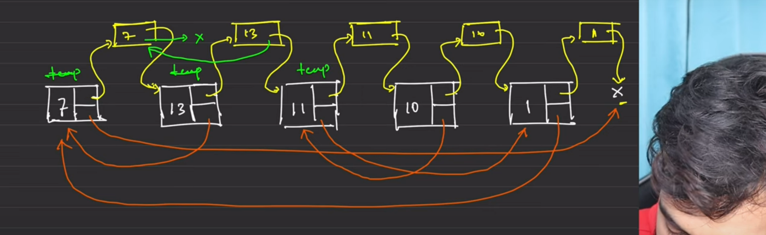

* so to solve this problem optimally we create new nodes and place them in between like this and then we first add the random pointers to these new nodes and then solve the problem of fixing the next nodes.
* The next nodes are fixed like we create a dummy node for the new linkedlist which we have to return and then separate out the main linkedlist and the new linked list and then we return the next of that dummy pointer as the main answer after deallocating the dummy pointer.

**Recursion:**

**Get a strong Hold:**

**Q1) Recursive implementation of atoi()**

* Give recursion the last index to work on.
* Recursion will bring you string to int converted number from 0 to n-2.
* You multiply it by 10 and add the element on index n-1 and this goes into the recursion with the base case that if it string.size == 0 then we return 0.

**Q2) Pow(x, n)**

* In this question we need to calculate x raised to n.
* We put n = abs(n) and then calculate x raised to n by the method.
* If n%2==0 then x=x*x and n=n/2.
* If not then ans = ans*x and n=n-1.
* This way the time complexity changes to (logn).

**Q3) Count Good Numbers:**

* A good number is a number whose even index has even digit and odd index has a prime digit.
* We have 5 options for even index and 4 options for odd index.
* If we are given a digit of size n how many good numbers are possible.
* In a n digit number even are (n+1)/2 and odd indexes are (n/2).
* So we calculate the number of even indexes and odd indexes and raise 5 to power of even and 4 to power of odd.
* To calculate power see previous question to calculate in (logn) time.
* We finally return after taking mod with 100000009 because answer can be too long.

**Q4) Sort a stack using Recursion:**

* In this problem we need to sort a stack using recursion.
* It is similar to sorting an array using recursion.
* We take the top element out and send the rest to recursion hoping it will bring sorted stack and then we call insert function to insert this value we had taken out at its correct position.
* So our base case will be if stack is empty return without doing anything or if stack has only one element it is already sorted.
* Then we take top out and run recursion to get the sorted stack and then we call the insert function to insert that top value at its correct position.
* The insert function is also a recursive function with the base case that if the stack is empty or the value on top of stack is less than the value we need to insert we simply push in the element in the stack.
* Otherwise we take out top and then call the insert function again till we are able to insert that element in its correct position.
* Once we have inserted the element at its correct position we push back the top we have taken out everytime in the insert function and then it is returned and the stack Is now sorted.

**Q5) Reverse a stack using Recursion:**

* In this problem we have to reverse a stack using recursion.
* To solve this problem we can take the exact same approach as that of last question.
* We will store the top in a variable and send the rest to recursion hoping it will reverse our stack and then we will just place our than temp at its correct position for which we will write an insert function.
* In the insert function we will take out the top and call recursion till the stack is empty where we will place our element.
* This goes on and we return the final stack.

**Subsequences Pattern**

**Q1) Generate all binary strings:**

* In this problem we have to generate all binary strings which have no consecutive 1’s.
* To solve this problem we use recursion as when n==0 we return “” and when n==1 we return 0 and 1. Now we make a new vector of string result and in it we store the new strings that can be formed like we have a 0 and a 1. We loop over this vector and add a 0 at the end as it will not cause any problem. So we get 2 strings. Now we will add a 1 at the end of the previous result but before that we need to check if the previous vector string had any 1 at the end of the string.
* Only those which had a 0 can attach a 1 at its end. So we insert all these new strings in a result and return it.

**Q2) Generate Parentheses**

* In this problem we have to generate all valid parentheses for a given n value.
* For ex for n=3, ()()(), ((())), (()()), (())(), ()(()) all these are valid.
* To solve this question we need to understand that we can add a open if it is less than n as we can put at max 3 open brackets for n=3.
* The second thing is we can put closing parentheses less than or equal to open we cannot have 1 more closing parentheses than open at any point of time.
* Our base case can be that if our string reaches 2*n then it is complete and we can push it in answer and return.
* The small work we do is check if open is less than n and close is less than open.
* If open is less than n then we update open++ and curr_string as curr_string+”(”.
* If closed is less than n then we update close++ and curr_string as curr_string+”)”.
* We keep doing this and we solve the problem.

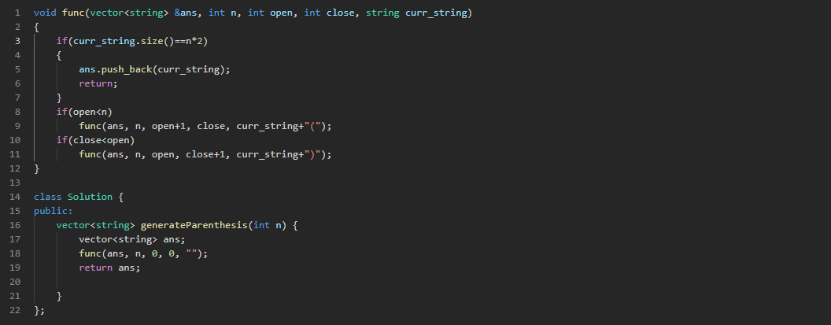

* Since this is an important question the code is right here.

**Q3) Print all subsequence/ power set:**

* In this problem we have to print all the subsequences of a given vector of integers and print them.
* To solve this question we have to follow an approach every time and learn this.
* You can either select that or leave that and once you select it you have to remove it as well. This is the whole crux.
* **Learn this structure by heart.**

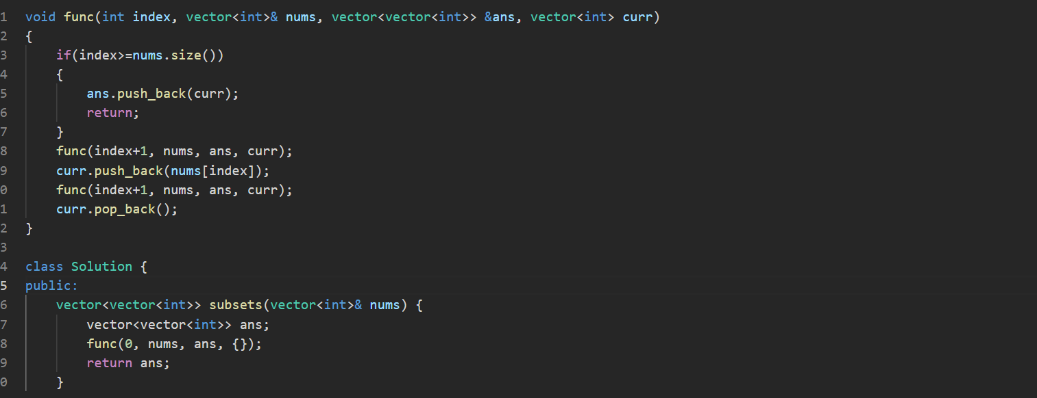

**Q4) Learn all Patterns of Subsequences:**

* In this problem we are given 2 strings and we need to calculate which string has more distinct subsequences and return that string as answer.
* If both strings have equal number of subsequences then return the first string.
* So to solve this question we take the approach of last question and calculate all the subsequences of both the strings and put them in a set and then in the end whichever set has maximum number of elements is returned as the answer and if both have same then the first string is returned as the answer.

**Q5) Count all subsequence with Sum K:**

* In this problem we are given an array of size n and we need to calculate count of subsequence whose count is equal to sum.
* So we calculate all subsequence by the format shown in Q3 and then we check if the sum calculated is equal to the sum we need.
* If it is then we return a 1 otherwise a 0.
* Also while calling the take or leave recursive function we store the value they return in l and r and then return sum of l and r in the end.
* This problem is optimally solved by DP.

**Q6) Check if there exists a subsequence with sum K.**

* It is same as previous question, instead of calculating all the count if we get even one true then we return true and from the recursive function if it returns true then we directly return true without calling the other function.
* For ex the moment you get a sum equal to k we return true and underneath where we call recursive function we check if true was returned after calling them and if it was then we directly return true without calling another one.

**Q7) Combination Sum – I**

* in this problem we are given an array of integer and we need to make combination such that we get a target sum.
* We can choose any index any number of times and we have to return all unique combinations only.
* To solve this question we again take help of that structure and put some conditions like if index == array length and target ==0 then we add it to our answer.
* We call the recursive function only if target is greater than the element of that array where index is situated. Then only we can include it otherwise we leave that and go to the next index.

**Q8) Combination Sum – II**

* In this problem we are given a vector of integers and a target number. We need to find unique combination in vector where sum of elements equals to target.
* Each element from the vector can be used once and the solution set must not contain duplicate combinations.
* This is the second type of structure problem of recursion, in this problem we are gonna use are second structure.

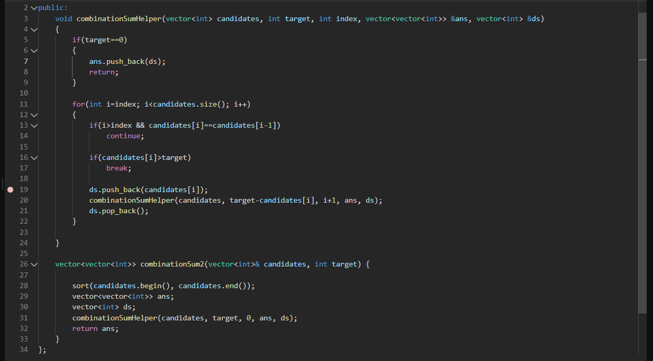

* in this structure we use a loop as well.
* In this problem we first sort the complete given vector as we want to add solution is set in sorted order.
* Then we send everything required to the helper function.
* In the helper function the base case would be if the target == 0 as then we have reached our sum required and we add that combination to our data structure.
* Then we go through a loop which goes from index to the end of the vector and we check if what we previously added in our data structure, is the next element also the same. If yes then we skip it and if the target is smaller than the current element we immediately break as any element on its right will also be greater.
* Then we once push_back and once pop it out.
* **In this structure we only have 1 recursive call.**

**Q9) Subset Sum-1**

* This is the same question as Q3. You have to return all possible sum of the subsequences formed of a given vector of integers.
* You use that structure and whatever sum you get when index == vector.size(), you store it in a vector and in the end you return that vector.

**Q10) Subset Sum – II**

* In this problem we are given an integer array which may contain duplicates and we need to return all subsets. Solution must not contain duplicate subsets but can be in any order.
* This question also belongs to the second structure of solving recursion problems.
* In this we will insert into ans at every step without base case and the loop will act as our base case as nothing next will be called.

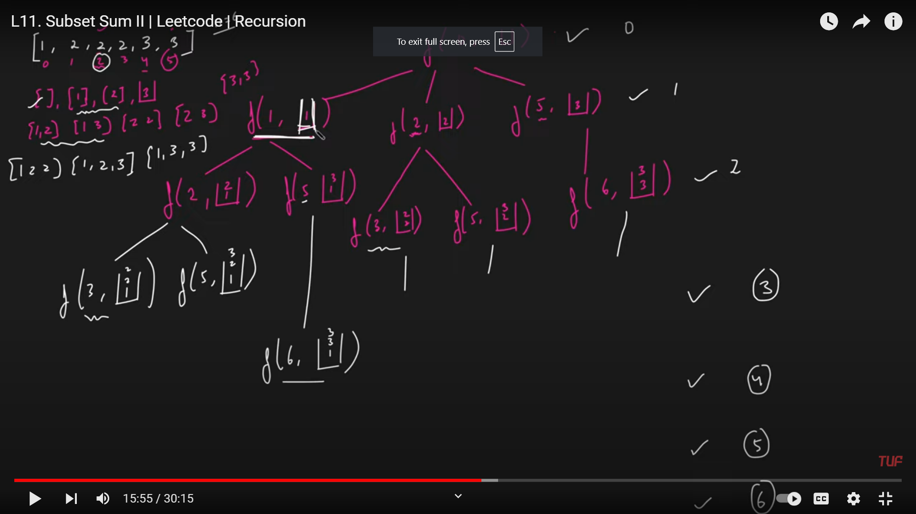

* In this problem we open this tree like this and we take only unique element and at each level we will have al unique combinations of that length. We will also sort the array in the beginning so that all same elements are together.
* We will add into ans at each step and then return it.

**Q11) Combination Sum – III**

* In this problem we are given a k value which refers to number of elements to be used while making the sum ‘n’ given in the question for ex if n==9 and k = 3 then possible answers can be [1,2,6],[1,3,5],[2,3,4].
* We can use the digits 1-9 and can only use a digit only once.
* This is also a 2nd type of structure problem in which we solve using recursion and loop.
* Base case can be if sum==n and k==0.
* We use extra variable to calculate the sum so far.
* And in the loop we go from 1 to 9 and we pushback whatever index is going and then increase index by 1. If it works well and reach base case we add it in answer otherwise if it exceeds sum we return and popback whatever we had added and then try for the next index.

**Q12) Letter Combinations of a Phone number:**

* In this problem we are given a string of digits and we need to calculate all possible letter combinations that the number could represent.
* 2-9, abc-wxyz
* This problem is also solved using the 2nd structure format.
* We make an ans variable and send to helper function. If size of digit is 0 then return empty.
* Then in the helper function the base case would be if index>=digits.size then whatever we have in the curr_ds will be pushed in final answer variable.
* Then we will take one digit at a time map it to its string and make a loop to iterate in that string.
* Then we will once add the character to our curr_ds and then call the recursive function and then when we return from it we pop_back().

**Hard Recursion:**

**Q1) Palindrome Partitioning**

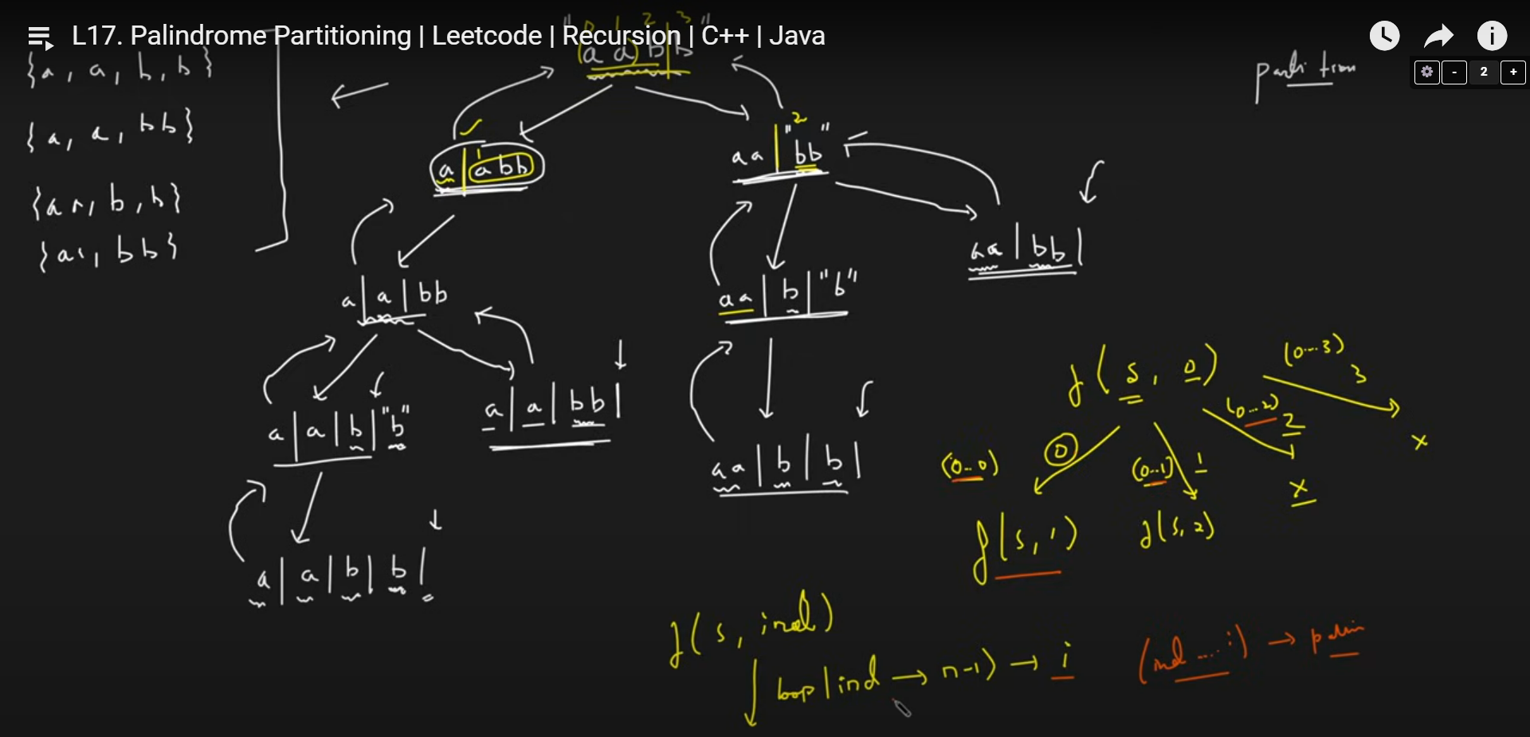

* In this problem we need to partition our given string such that all substrings formed are palindrome.
* To solve this question we will use the second structure of recursion.
* We will start index from 0 and the base case would be if index == string.size then add the string thus formed in our answer and return.
* Otherwise we iterate in a loop which goes from 0 to string size. We will try to partition at different spots and check if partitioning here the substring we get, is it a palindrome or not.
* If it is then we go forward otherwise we do not partition there and move forward.
* And if we have partitioned then we call the recursive function in which we check the same for the string left and then we also pop_back() to get the next case where we check if even bigger substring can be palindrome.
* See the tree above and the code for more clarity.

**Q2) Word Search:**

* in this problem we are given a 2d character array nd we need to search for a word inside the array.
* If the word is present return true else false.
* In the first step we go to each index and see if we get the character that we are looking for.
* If the word starts with ‘A’ then we find an ‘A’ in the character array by linear search over the whole 2D array.
* When we find the first letter, we can mark it with our custom symbol to remember we have already traversed on this spot so that we don’t reuse it.
* Then we keep finding for the next elements In all 4 directions and backtrack if we don’t find and if we backtrack from a spot where we left our special symbol then we have to restore the character that was initially there.
* We need to make a check function which will check for out of bounds, if already visited index or if the wrong character due to which we will backtrack.

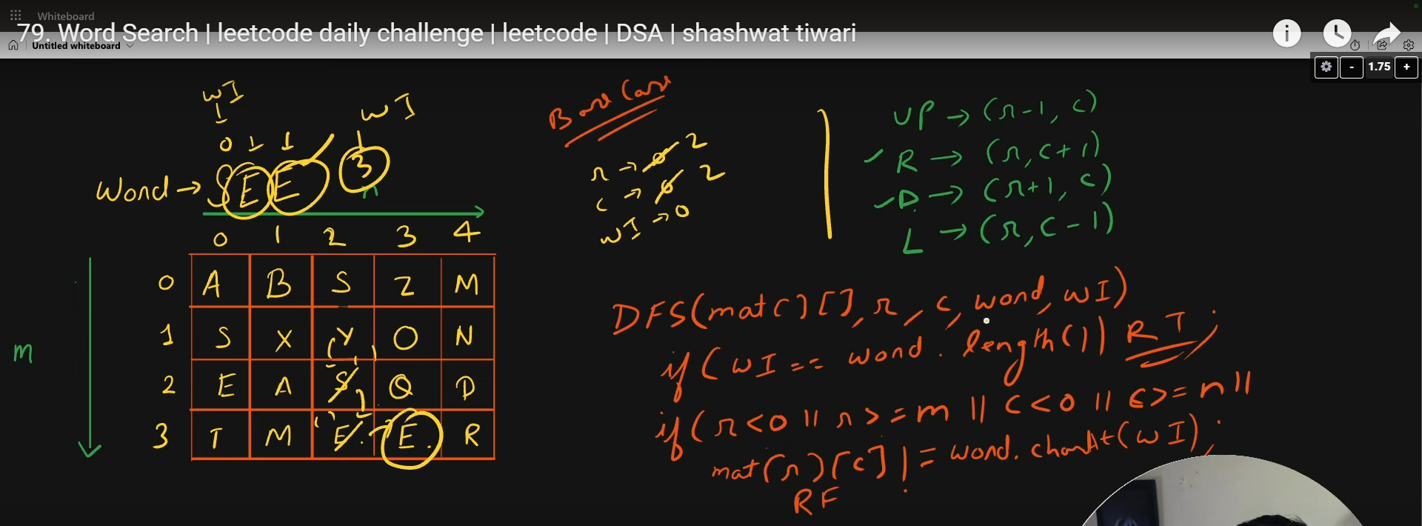

**Q3) N-Queens:**

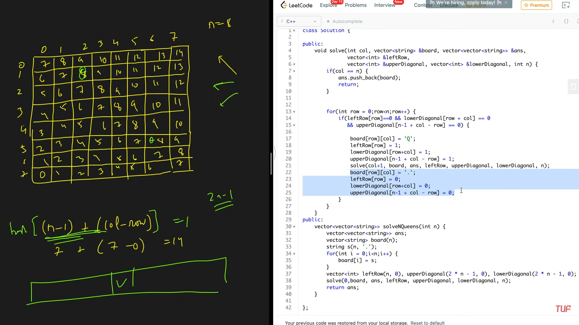

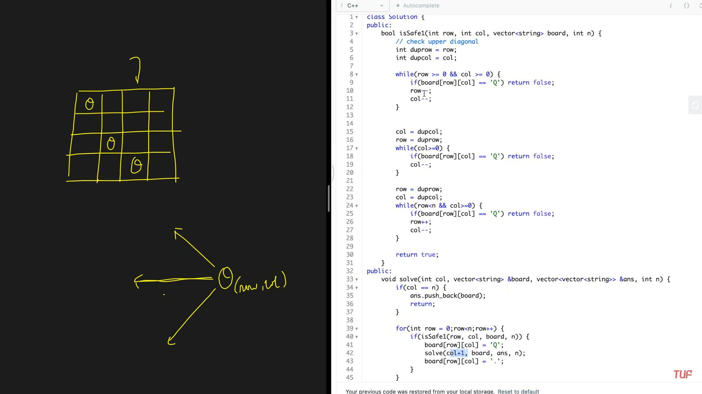

* This is a very important and famous question.
* In this question you have to put n queens in a n*n chess board.
* So there should be 1 queen in each row and each column and no 2 rows and columns should have queen each
* Also we have to make sure of the diagonals.
* We have to make sure of the north west, west and south-west direction if queen is present or not as we will be filling queens from left to right so obviously there will be no queen to the right side.
* Now there can be 2 solutions, In one solution we are gonna use a loop to check these 3 directions one by one but this will take a lot of time as we have n*(3*n) time complexity atleast.
* The efficient way to do this question would be to use hashmap.
* In the hashmap you can check the three directions by:
  + **West :** create a hashmap of length **n** which stores whether that row has a queen or not. If it has then put a 1 else a 0.
  + **South-West**: create a hashmap of length **(2*n)-1** and now when you put a queen check its row and column value and put a 1 at the sum of the row and column. Now you cant put a queen at this sum as it will lie on the diagonal.
  + **North-West:** create a hashmap of length **(2*n)-1** and use the formula of **(n-1) + (col – row)** to fill the diagonals. Now if you have put a queen at a spot use this formula to get the value and then in the hashmap put that spot to be 1 and then next time you are putting a queen use this formula to check if it is already occupied.
* This way now you have checked all three directions and if there is no problem then put a queen there.

**Bit Manipulation:**

**Learn Bit Manipulation:**

**Q1) Introduction to Bit Manipulation [Theory]**

* To get the ith bit we will use the bitwise operation. ((num & (1<<i))==0) ? 0 : 1;

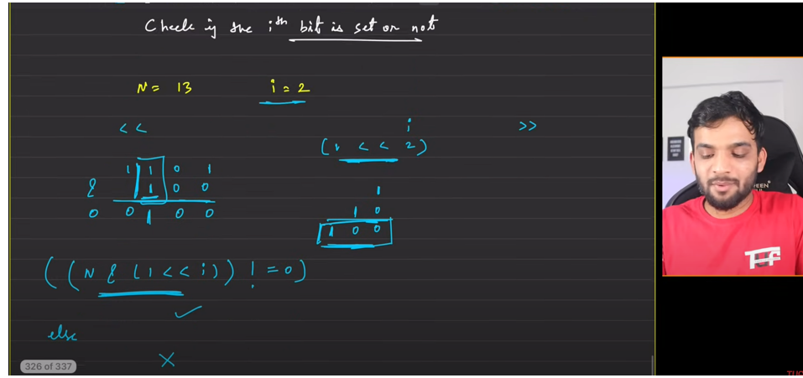

* To set the ith bit we will use the bitwise operation. (num | (1<<i));
* Here we will put a 1 below where we need to set and then do a OR operation if it is set then it remains set and if it was 0 it becomes 1.
* To clear the ith bit we use the bitwise operation of (num & ~(1<<i));
* Here we will create a 0 below what we need to clear and rest all will be 1 and we will perform the AND operation and this operation gives 0 whether it was set or unset.

**Q2) Check if the i-th bit is set or not**

* Same as Q1 part a.

**Q3) Check if a number is odd or not**

* to check if a number is odd or not we can perform AND operation of that number with 1 and if it gives 1 then it is odd number otherwise it is even number as only odd number can have 1 at the ones place.

**Q4) Check if a number is Power of 2 or not:**

* To solve this question we can perform (N & (N-1)).
* Since if a number is a power of 2 It will only have 1 set bit in its binary equivalent.
* So we subtract 1 and do AND operation and if it has no more set bits on the left then overall will be 0. If anything else is returned then it is not power of 2.

**Q5) Count the number of set bits**

* In this problem we need to find the number of set bits from 1 to n for each number.
* For each number to find the number of set bits we select the number and then keep clearing the rightmost bit till the number becomes 0.

**Q6) Set/Unset the rightmost unset bit**

* just return (n | (n+1)) and we can set the rightmost unset bit.

**Q7) Swap two numbers**

* We can use bitwise operators to swap two numbers by:

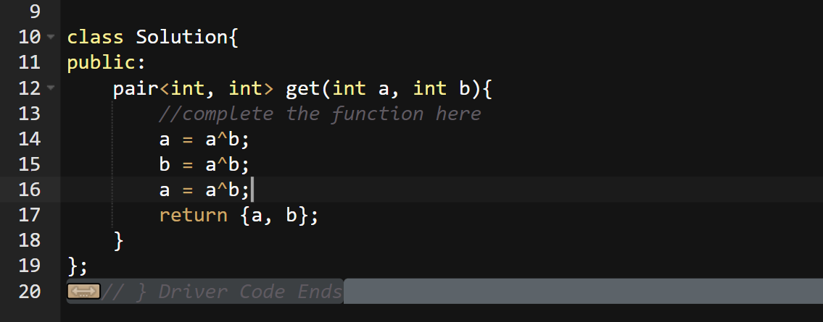

**Q8) Divide two integers without using multiplication, division, and mod operator**

* One naïve solution can be to add divisor to itself till it is almost equal to the dividend and return the count.
* **The optimal solution:** the optimal solution would be to first make all positive.
* Then we have to subtract powers of 2 from the dividend starting from the highest possible.
* Then the max that we were able to subtract, we add that power to our ans and this way we break the complete answer in powers of 2.

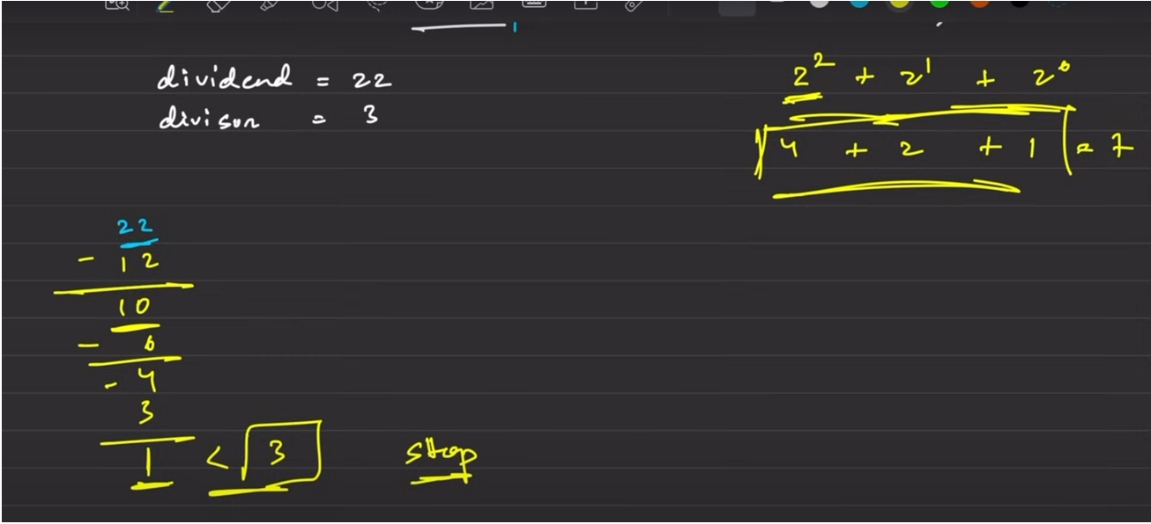

**Interview Problems of Bit Manipulation:**

**Q1) Count number of bits to be flipped to convert A to B**

* To convert a number A to B we have to calculate how many bits we have to flip.
* To solve this question what we can do is XOR A and B and we will get a new numbers which will have only set bits of those places which were different in both A and B.
* So after calculating this we calculate how many set bits it contains and then return it.

**Q2) Find the number that appears odd number of times**

* In this problem we have to return the number that appear odd times.
* As only one number odd times all other appears even times.
* If we do XOR of all elements in the array then only the number which appeared one time will remain and return it.

**Q3) Power Set**

**Q4) Find xor of numbers from L to R.**

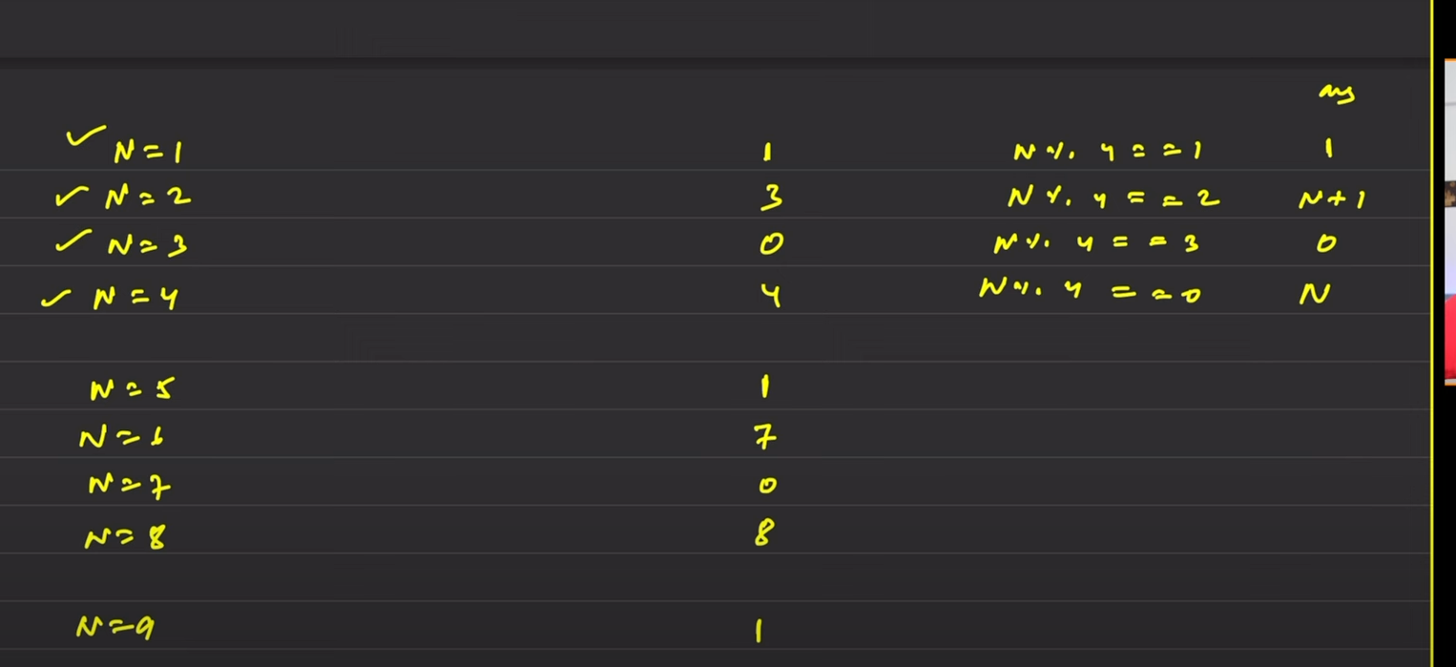

* You have to remember this table to solve this question.

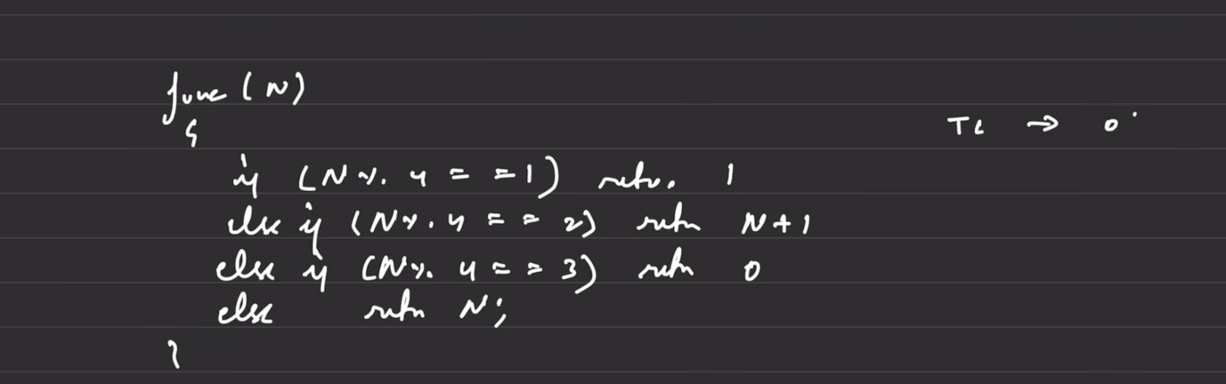

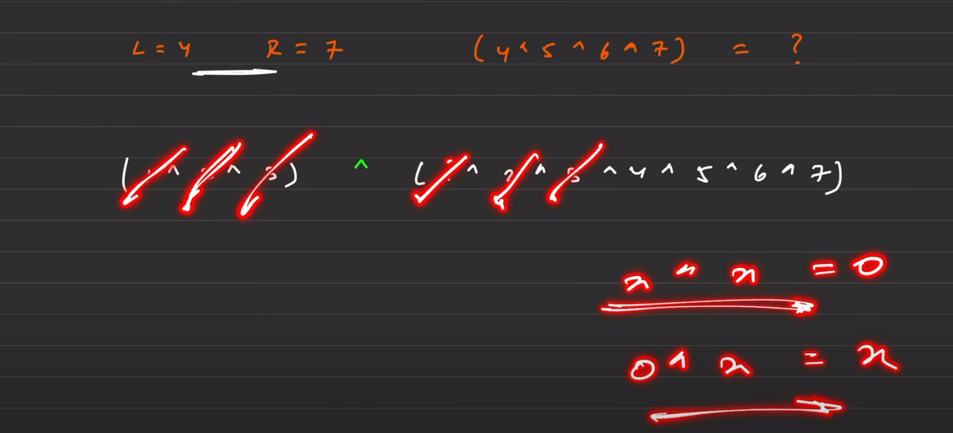

* The above is the solution from 1 to N. If we have to calculate from left to right then we calculate from 1 to left-1 and then from 1 to N and subtract these 2.

**Q5) Find the two numbers appearing odd number of times**

* In this problem we are given 2 numbers which appears odd number of times and all else appears even number of times.
* Return those 2 numbers.

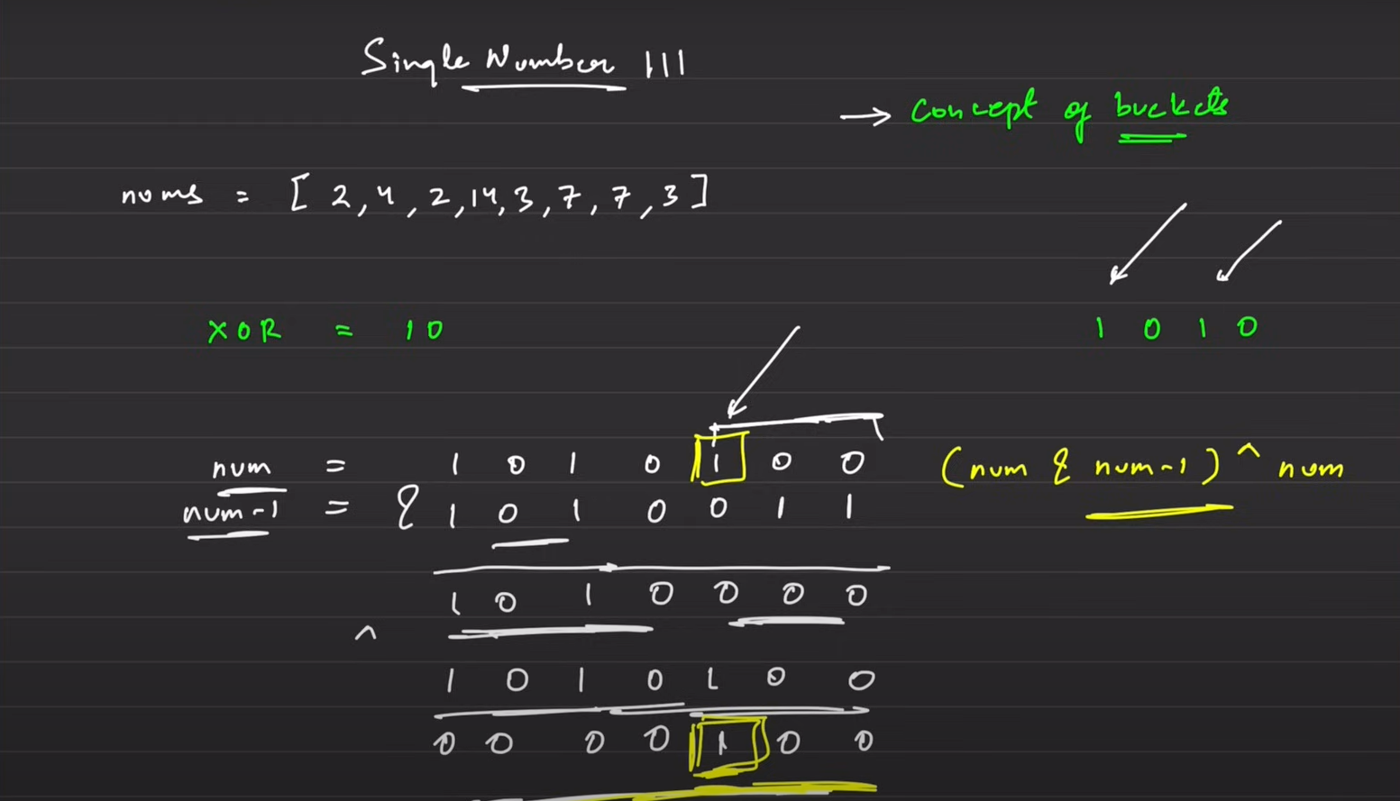

* In this problem we have to use the bucket approach. We can see as all other appear 2 times they will cut each other off and only 2 will remain.
* So we need to separate these two numbers from each other and that is why we will create a bucket.
* In this bucket the two different numbers will definitely have 1 bit difference at the minimum.
* We will use the rightmost different bit to divide the given sample space in 2 parts and now the different number will lie in different buckets and only they will remain after we XOR these two buckets.

**Lecture 3: Advanced Maths:**

**Q1) Print Prime Factors of a Number**

* A possible solution is go from 1 to (n)1/2 and then see if that number divides it and if yes then check if it is prime, if again yes then it is otherwise not.
* A second solution can be to go from 1 to (n)1/2 and then check if it divides then we know that n/i will also divide that number so we check for prime for these 2 numbers everytime. Also we make sure n/i is not i itself.

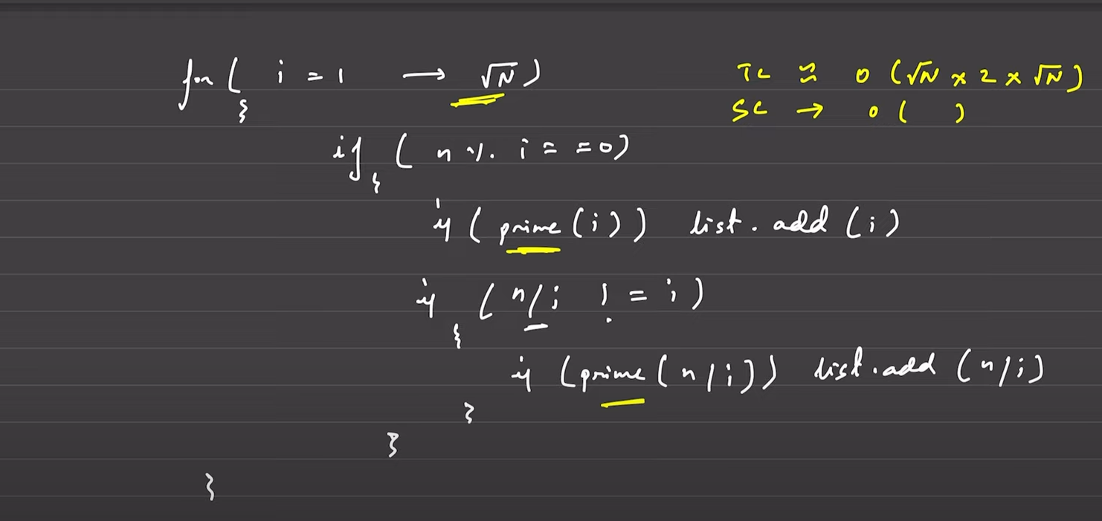

* Another approach can be to create code for the school way of doing it like this.

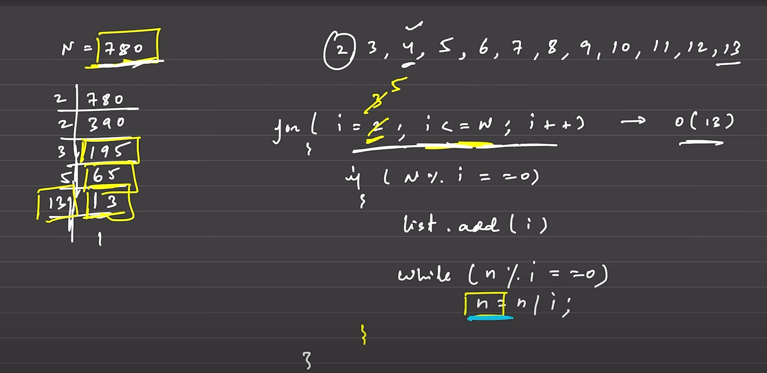

* This has time complexity very less but for large numbers which are prime itself time complexity is of O(n).

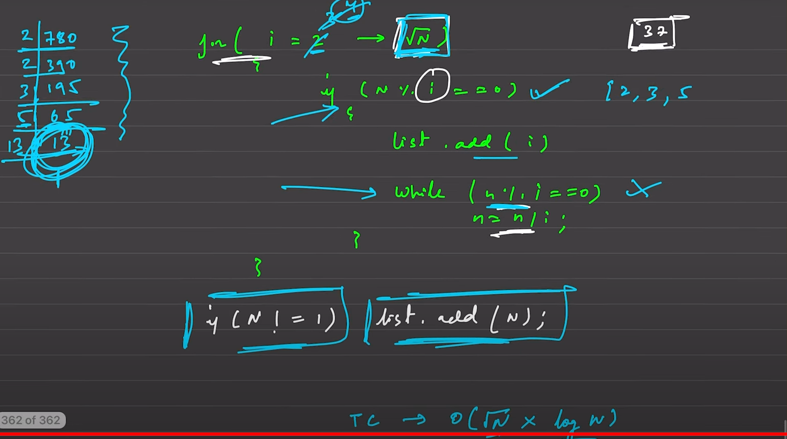

* This is the most optimal solution. In this solution we go till (n)1/2 (inclusive) instead of till n and in the end check if the n has reduced to 1. If it has then we end then and there otherwise we add n to our answers.

**Q2) All divisors of a Number:**

* To solve this question you are given a number and you need to print all divisors of that number.
* It is an relatively easy question you just need to check from 1 to (n)1/2, if that number is divisible by i and if it is then you need to add that number as well as n/i to the answer.

**Q3) Sieve of Eratosthenes:**

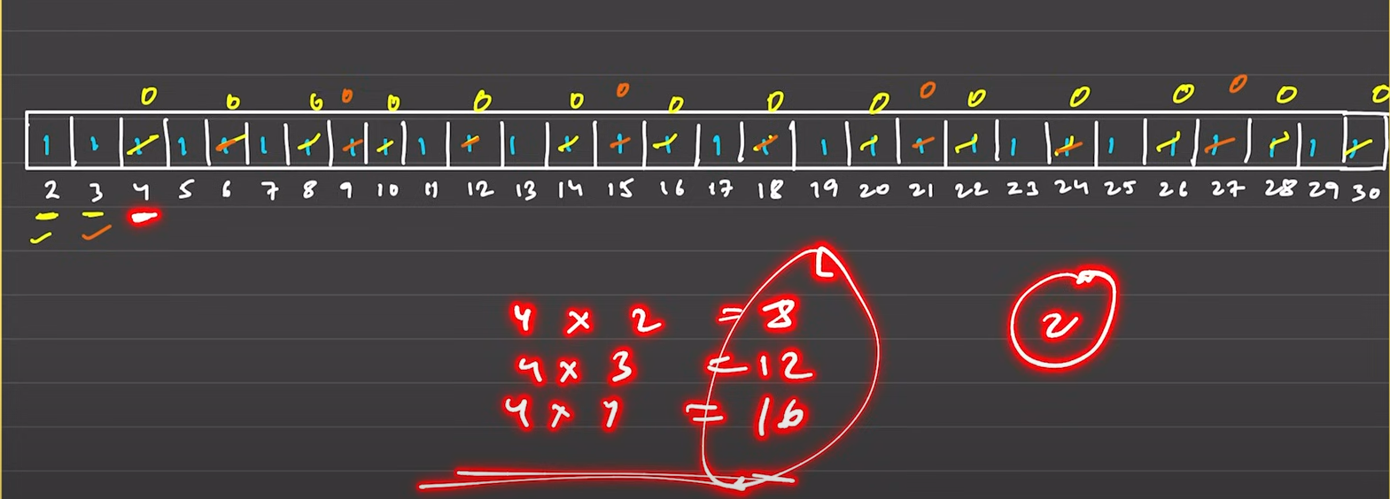

* In this problem you have to make a big array till the given n and mark everything as 1.
* Then you have to traverse from 2 and check if it is 1 or not. If it is then you have to traverse on its multiples and set all to 0 and repeat this.
* Then all the left 1’s are prime numbers.
* The 2 modifications that you can do are:

1. Instead of going from 2*i you can go from i*i as all previous would have been already computed.

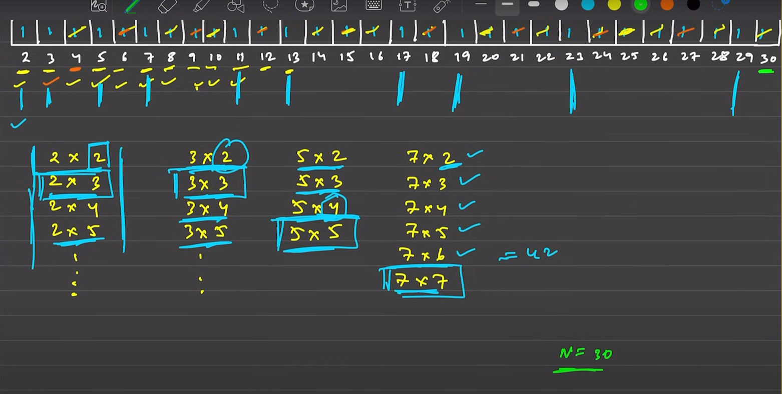

1. Instead of going till n and checking every we can go till root(n) as all other will be greater than n when we multiply i*i.

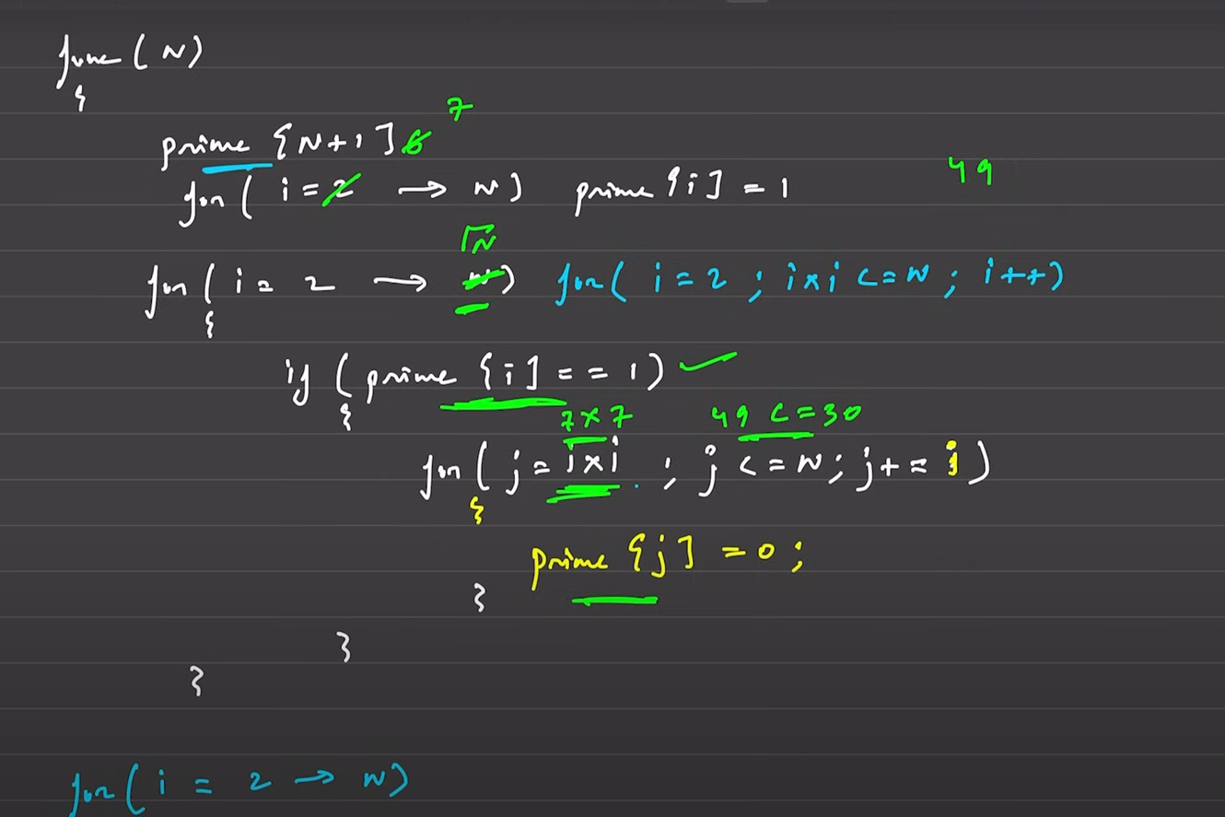

**Q4) Prime Factorization using sieve:**

* It is somewhat similar to last question. In this question we need to print all the prime factors of the given number.
* We can create a sieve of prime but the difference is we create a n+1 size array and set its data to the index.
* Then we start from 2 and go till n and we check if the number is placed on its index we leave it as it is a prime number and on all the rest multiples of that number we put that number itself again. For ex: if we are checking for 2 we leave index 2 as it is with data 2 and on all next indexes like 4,6,8 etc we put 2.
* This goes on and in the end we just normally divide the number by the data put on its index.

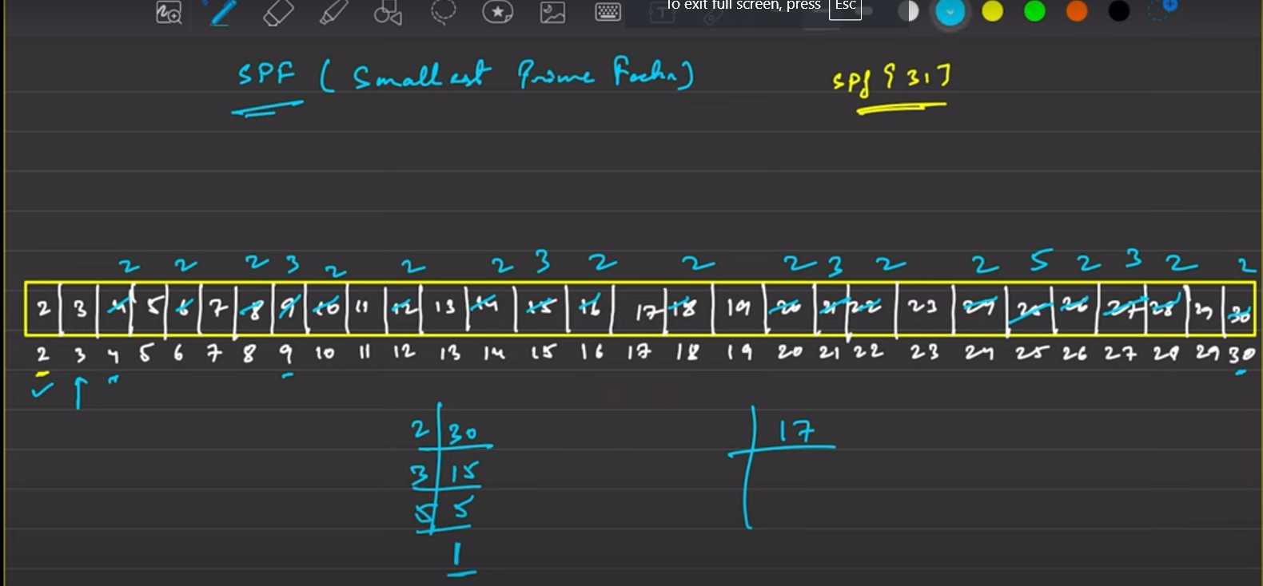

**Q5) Power Exponential:**

* You need to calculate power of a number like x raised to n.
* Either you can use the STL pow(x, n), or else.
* You will convert odd power into even by breaking 1 and storing it in answer and the rest even part is divided by 2 and the x is squared.
* Ex:

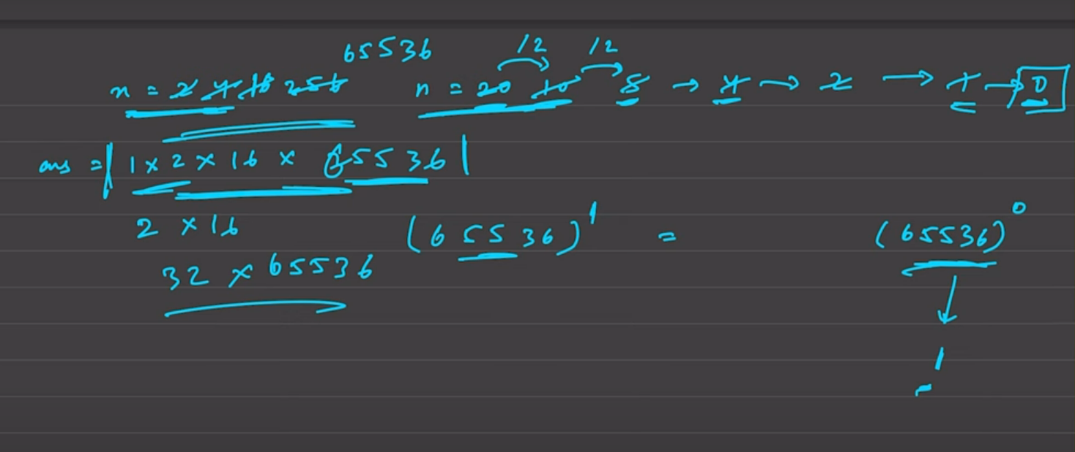

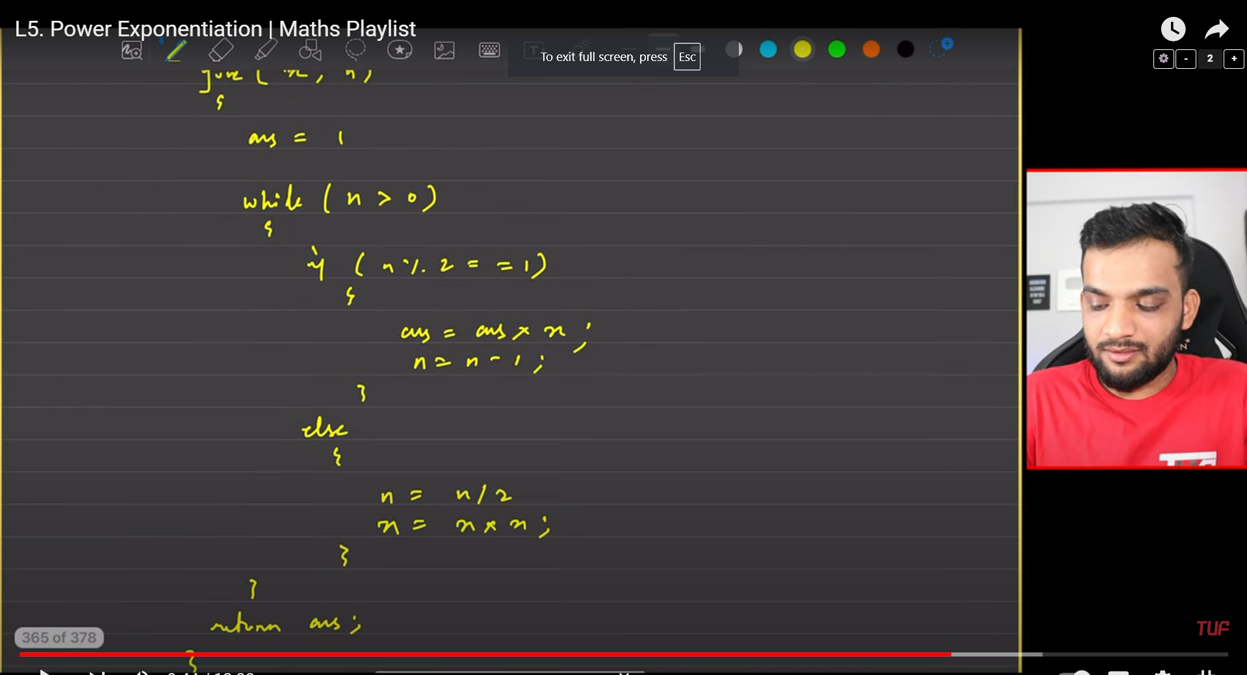

**Stacks and Queues:**

**Learning:**

**Q1) Implement Stack using arrays:**

* In this problem we need to implement stack using arrays.
* We have an array of size 1000 and a top variable which stores where the top element is stored in the array.
* When we want to push something in the array we move top one place ahead and store it there.
* When we want to pop something from the stack we move our top variable one step back and also store that element to be popped in a temp variable and return it.
* Also if top is at less than 0 then we return -1.

**Q2)** [**Implement Queue using Arrays**](https://takeuforward.org/data-structure/implement-queue-using-array/)

* In a queue FIFO is followed.
* You enter from the rear and exit from the front.
* We have an array arr and a front and rear variable. Front and rear starts from -1.
* When we need to add an element in the queue then we add the element and then move rear by 1 position, but optimally we

should use the **Aditi’s** formula (rear+1)%(size of the queue) to optimally use the queue’s size as the rear comes in front after we pop out a few elements and rear has reached its end.

**Q3) Implement stack using Queue:**

* In this problem you have to implement a stack using 2 queues.
* We will create 2 queues and then while pushing we will move all elements of q1 to q2 then insert new data to be pushed in q1 and the return all elements from q2 to q1.
* For pop we simply pop the q1 and return if needed.
* For top we simply return the front of the q1.
* For empty we check if q1 is empty then we return true.
* **If we want to do it using a single queue then the pop, top and empty remains same. Just the push changes we simply push the element and then we rotate the queue till that element comes to the front of the queue.**

**Q4) Implement Queue using Stack**

* All the methods are same as above using 2 stacks instead of using 2 queues.

**Q5) Implement stack using linked list:**

* In this problem to make the push command you create a top and assign in to NULL. Then everytime create a new node and put newNode->next = top. And then update top to be newNode.
* To make the pop command you simply pop the top and deallocate its memory and return the data if required.

**Q6) Implement Queue using Linked List.**

* In this problem we are given a front and a rear.
* We create a new node and then check if it is the first node. If it is then we set front and rear to this node. Else we put rear->next as the newNode and then move rear one place ahead.
* For the pop command we check if rear and front both are null then we return -1. Otherwise we store the data of front if required to return and deallocate that front node and move front one step ahead. Also make sure that if this is the last node then set the front and rear back to NULL.

**Q7) Check for balanced Parentheses:**

* In this problem we are given a set of brackets and we need to return if it is a balanced parentheses set or not.
* We will create a stack and we will simply push every left bracket.
* If we encounter any right bracket then we check if at top the same type of left bracket is there.
* If it is then we pop it out and if stack is empty then we return false and if on the top some other left bracket is there then also we return false.
* If at the end stack is completely empty then it is balanced and if even one element remains then it is not balanced.

**Q8) Implement Min Stack:**

* In this problem we have to create a stack but it should contain the a function to directly call the minimum value in stack in O(1) time complexity.
* One way is to store pair in the stack with the second number being the minimum in the stack encountered so far.
* Second way is a little difficult:

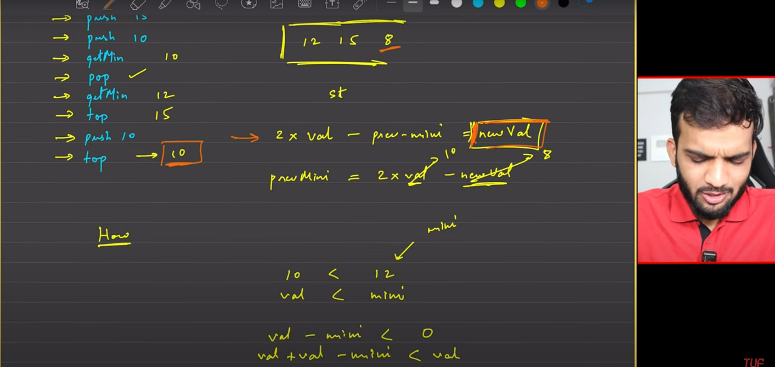

In this problem we are not pushing the exact value when we find a minimum and instead compute using this formula and push that in the stack as then we can keep a track of the previous low.

Hello World